Subsidiary Mathematics
SENIOR FIVE term 1

TOPIC 1/3: Matrices

Sub math matrices Matrices
A matrix is a regular arrangement of array of numbers called elements or entries. The plural of matrix is matrices.
Matrices are named by capital letters and the elements y small letters. For example
P = 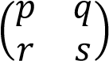
The order of matrix
The of a matrix is stated by the number of rows and the number of columns. A matrix having p rows and q column is called a p x q matrix written as p x q. For example O = 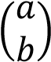 has order 1 x 2
P = 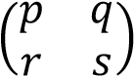 has order 2 x 2
- = 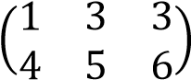 has order 2 x 3
- 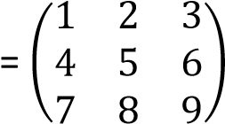 hasorder3 x3

Types of matrices
- Row matrix has only one row e.g.
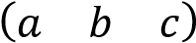, 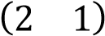, etc.
- Column matrix has only one column e.g.
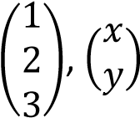 etc.
- Square matrix has the same number of rows as columns
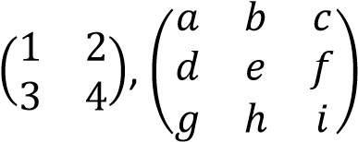, etc
- Equal matrices have equal corresponding elements, e.g. 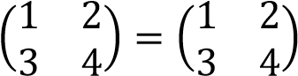
- A Zero (or null) matrix has all zero elements
e.g. 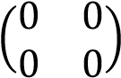
- An identity matrix or unity matrix is a square matrix whose every element leading (principal) diagonal is and whose every other element is zero. It is denoted by I, e.g.
I =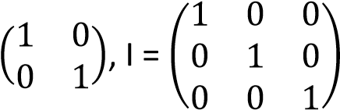

Operation of matrices AI = 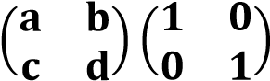
Given A =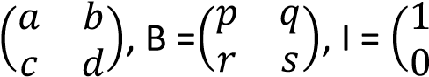 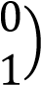 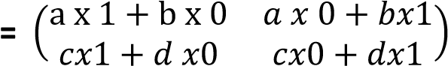

(a) Addition of matrices 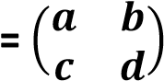
- + B = 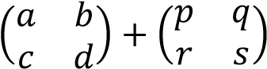 IA 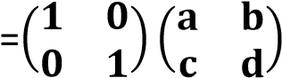
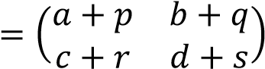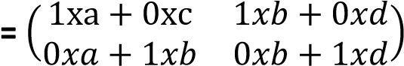
- + A = 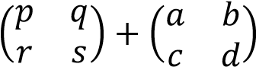 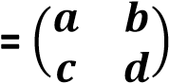
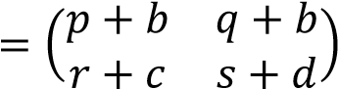
Note that AI = IA = A

Note that A+B = B + A (e) Determinant of a matrix (b) Subtraction of matrices Given that A =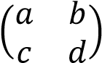
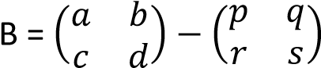
Determinant of A is denoted by
- ⁻ det(A) or=ad – bc
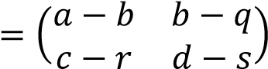
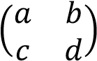
(f) Inverse of matrix

Given that A =
- – A = 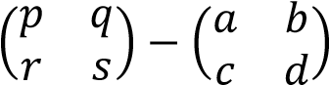 Adjunct of A = 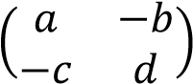
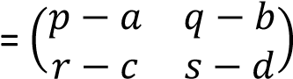
Inverse of A is denoted by A⁻¹ A-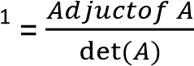
Note A – B B – A

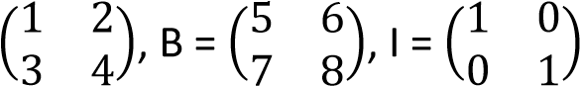
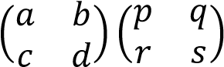
Example 1

(c) Multiplication of matrices
Given that A =
AB =
Find
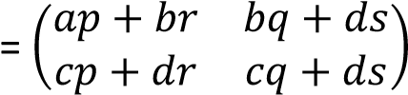 (i) A + B 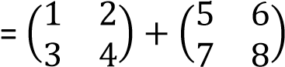
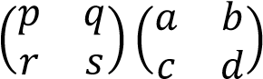
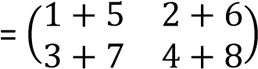
BA =
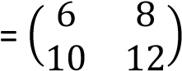
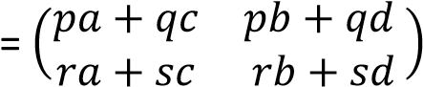 (ii) B + A =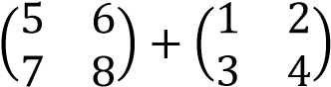
Note that AB BA 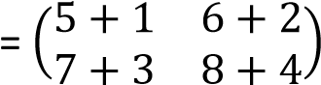
Hence the commutative property does not apply for matrix
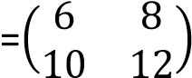
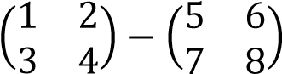
(iii) A – B = =

(d) Multiplication of a matrix with and identity
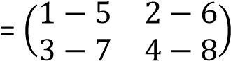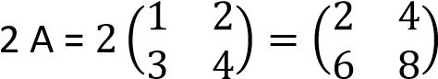
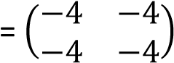

(iv) B -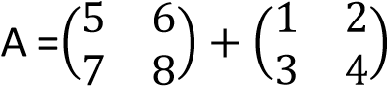 Example 2
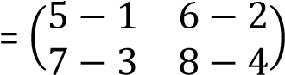 Given that A = 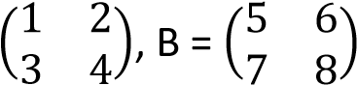, find
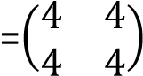 (i) A⁻¹
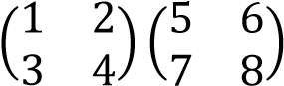
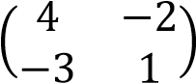
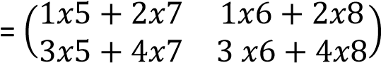
- AB =
Adjunct of A =

Det(A) = 1 x 4 – 2 x 3 = -2
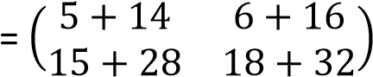
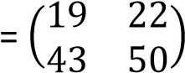
A⁻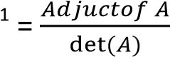

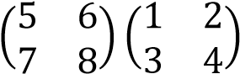
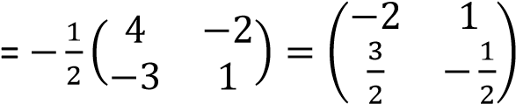
- BA = B₋₁
(ii)
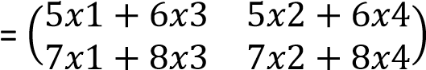 Adjunct of B =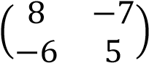
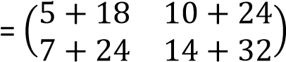 Det(B) = 5x8 – 6 x 7
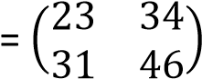
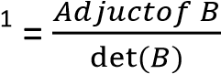
= -2

-
- BI = 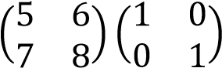 ^{B}
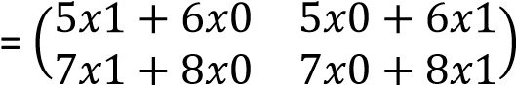
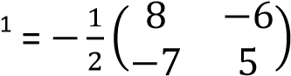
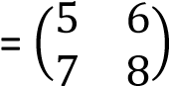
B⁻

- IB = 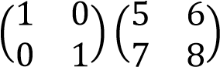 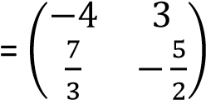
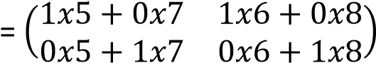
(iii) (BA)⁻¹

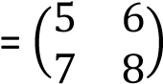 BA =
From (vii) and (vii), BI = IB = B 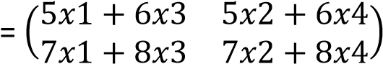
- Det(A) 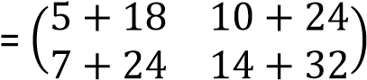
A =

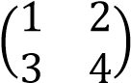
Det(A) = 1 x 4 – (2x3 )
= -2 Adjunct of BA = 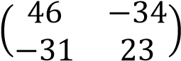
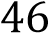
- Det(B) given B = 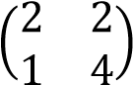 Det(BA) = 23 x 46 – 34 x 31 = 4
Det (B)= 2 x 4 – 1 x 2 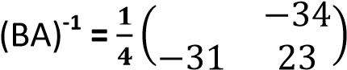
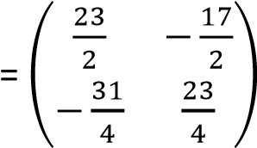
= 6
- 2A

Example 3
Given the matrices
A = 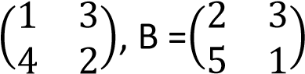and C = 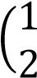 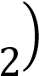, find
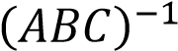
Solution
ABC = 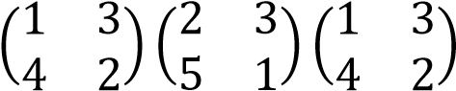
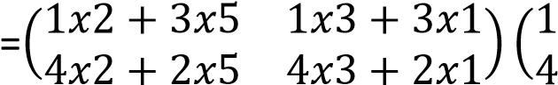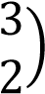
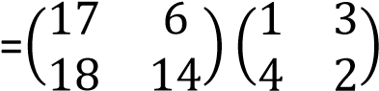
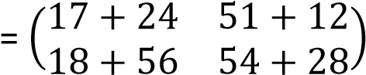
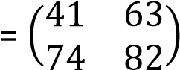
Det(ABC) = 82 x 41 – 74x63 = -1300
Adjunct of (ABC) = 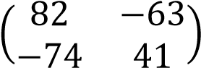
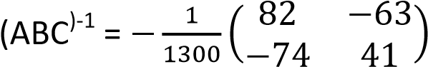
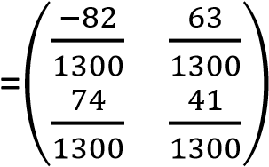

Example 4
Given that A = 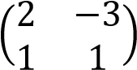 and B = 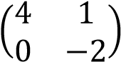.
Find
- AB 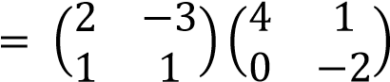 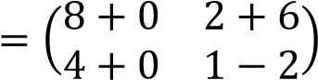
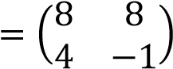
- BA 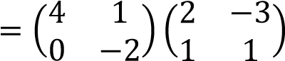
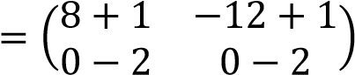
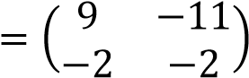
Comment on your result (05marks)
AB BA; hence the commutative property does not apply for matrix

Example 5
The matrix A = 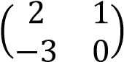 and I is a 2 x 2
Identity matrix.
Determine the matrix B such A² + ½ B = I
(05marks)
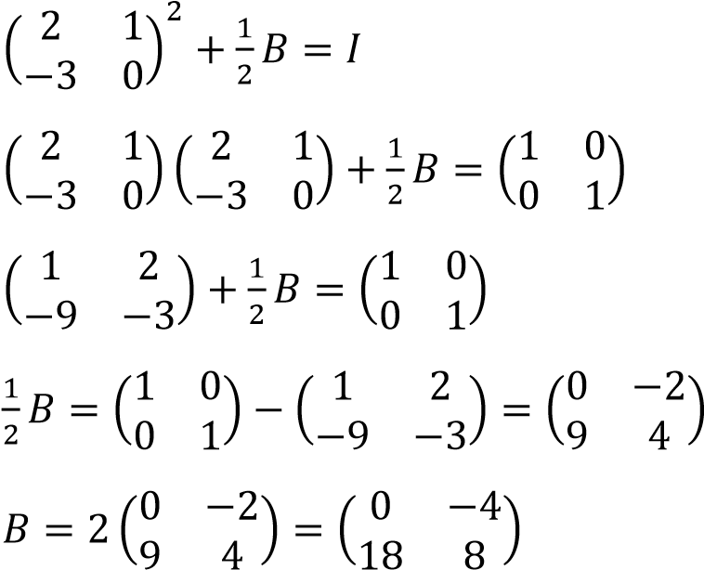
Hence matrix of B =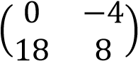

Example 6
Given the matrices A = 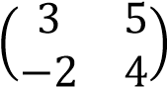 and
B = 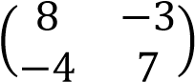, find
- matrix C such that 3A – 2C + B = I, where I is a 2 x 2 identity matrix.(03marks)
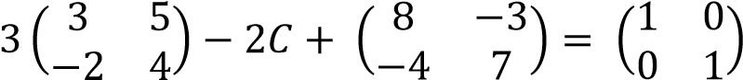
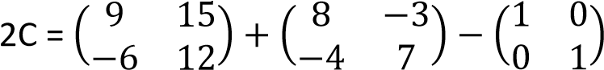
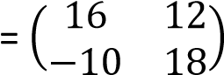
C = 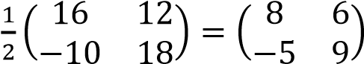
- the determinant of C. (02 marks)
Det (C) = 8 x 9 –(-5 x 5) = 72 + 30 = 102

Example 6
The determinant of the matrix
P = 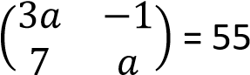

(a) Find the value of a. (03 marks)
= 3a x a - (7 x -1) = 55
3a² + 7 = 55 3a2 = 48 a2 = 16 a = 4
Using one of the value of a, determine the inverse of P.
P =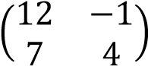
Adjunct of P = 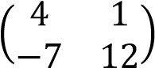
= 48 – (7x-1) = 55
Inverse of P⁻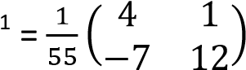
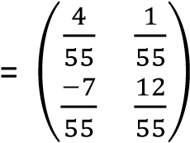

Revision Exercise1
(Answers are given in square rackets at the end of each question)
- Given that A = 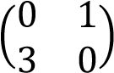 and B =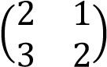
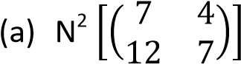
  - MN 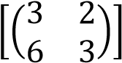
  - The value of scalar k if N² + kN MN [-2]
- Given that P = 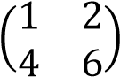, Q = 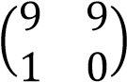 and
R = 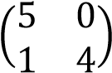
Find (PQR)-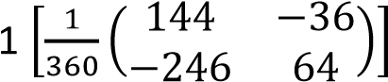
- 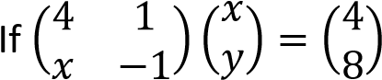, determine x and y
[x = -6 or 2 and y =28 or -4]
- Given A = 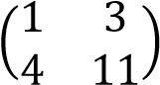 and B = 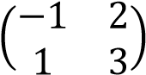
Find
  - AB 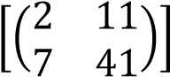
  - 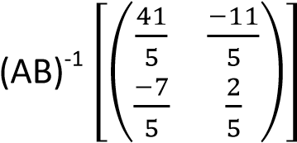
- If matrix P and Q are such that
P = 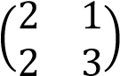 and PQ = 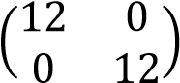
Find Q 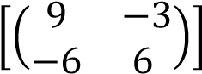
- Given the matrix P = 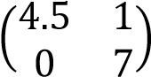 and
Q = 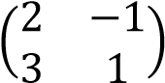
Find matrix R such that 3R -1I= 2A – B,
where I is an identity of order 2. 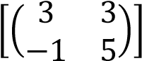
- Given that P = 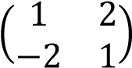, Q = 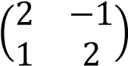, find
PQ-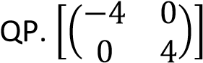
- 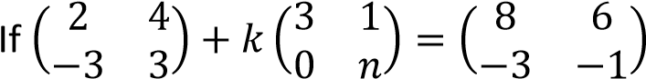, find the values of k and n. [k=2, n = -4]

Using matrices to solve simultaneous equation

Example 7
Using the matric method, solve the simultaneous equations. 3x – y = 16 x + 2y = 3 (05marks)

Solution
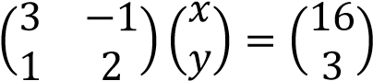
Let A = 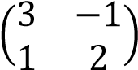
Adjunct A =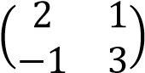

Det(A) = (3 x 2) – (-1 x 1) = 6 + 1 = 7 Forming matrices
A⁻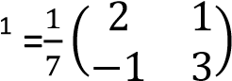 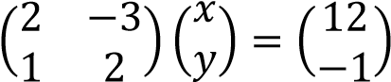
Pre-multiply both sides with the inverse Let P = 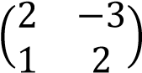
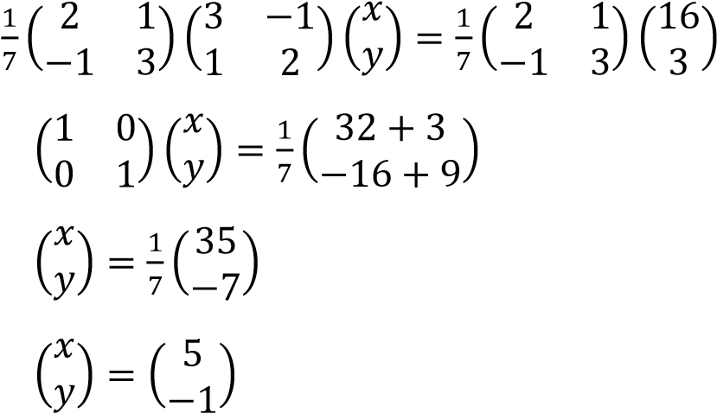
Det(P) = (2 x 2) – (1x -3) = 7
Adjunct of P =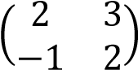
P⁻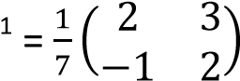
Pre-multiply both sides with the inverse
Hence x = 5 and y = -1 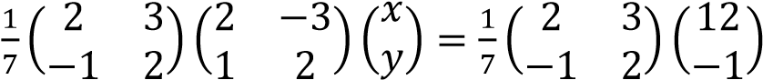

^{Example 8} 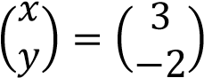
Using the matric method, solve the
Hence x = 3, y = -2 simultaneous equations.

2x -3y = 12
x + 2y = -1

Example 9
A family bought the following items for three successive days. The first day it bought three bunches of matooke, two kilogram of rice, five kilograms meat and two kilogram of sugar. The second day it bought one kilogram of sugar. The third the family bought a bunch of matooke and two kilogram of rice. A bunch of matooke costs shs. 15,000. A kilogram of rice, meat and sugar cost 3,300, shs 8,000 and shs 3,000 respectively.
- represent the family’s requirements in a 3 x 4 matrix
Purchase

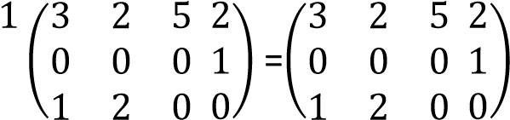
D B R M S
- write down the cost of each item as column matrix
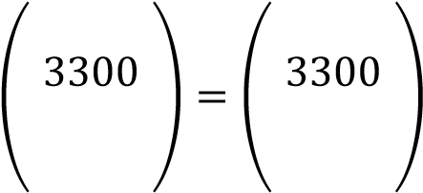
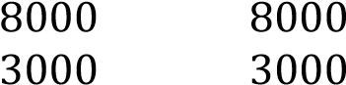
Item costs
B
^{R}
M S (iii) Use the matrices in b(i) and b(ii) to find the family’s total expenditure for the three days. (10 marks)
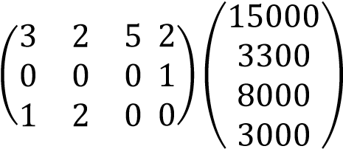
= 3x 15000+2 x 3300 + 5 x 8000 + 2 x 3000 + 1 x 3000 + 1 x 15000 + 2 x 3300
= 45000 + 6600 + 40,000 +6000 + 3000 + 15000 + 6600
= 122,200

Example 10
Given that M = 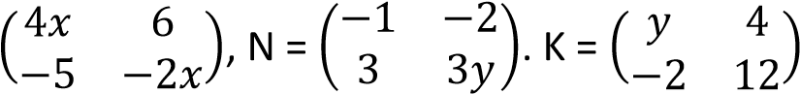 and K = M + N,
find the value of x and y. (07marks)

Solution
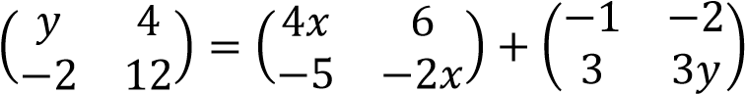
y = 4x – 1 ……….(i)
12 = -2x + 3y…….(ii)
Substitution of (i) in (ii)
12 = -2x + 3(4x -1)
12 = -2x + 12x – 3 10x = 15 x = 1.5
Using equation (i) y = 4 x 1.5 – 1 = 5
Therefore x = 1.5 and y = 5
(b) In a football tournament, three teams Arsenal, Chelsea and Liverpool gad the following results
- Arsenal won two matches, drew once and lost one match
- Chelsea won two matches and lost two matches
- Liverpool won 1 match, drew twice and lost one match.
The teams are awarded 3 points of a win, 1 point for a draw and no point for a loss.


- Write a 3 x 3 matrix for the results and a column matrix for points. (04marks) W D l
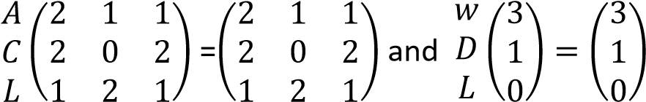
- By matric multiplication, determine the winner of the tournament. (04 marks)
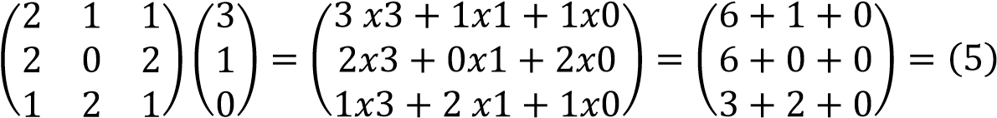
Asernal won with 7 points
Revision Exercise 2
(Answers are given in the square, [ ] brackets at the end of each question)
- Use matrix method to find the values of x and y
(a) 2x – 3y = 12 x + 2y + 1= 0 [x =3, y = -2] (b) 2y – 4x + 2 =0
3x – 2y = 5 [x = -3, y = -7]
(c) 2x – 3y + 5 = 0 x + 2y - 8= 0 [x =2, y = 3] (d) 4x + 5y = 13
3x – 2y = 4 [x =2, y = 1]
  - 4y – 3x = 9 x – 2y = -5 [x =1, y = 3]
  - 3x + 2y = 8
3y + 4x = 11 [x = 2, y=1]
- Given that matrix A = 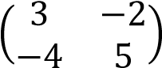 fin a matrix B such that AB = 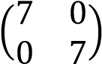. Hence or otherwise find the
inverse of matrix A 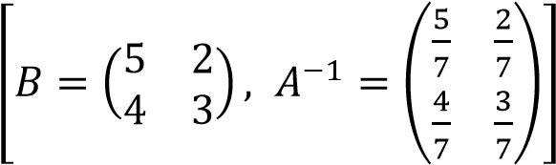
- Given that matrix, P = 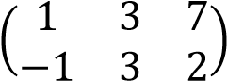and Q =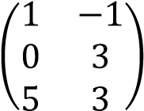, find matrix R such that R = PQ. 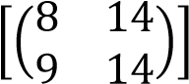

TOPIC 2/3: Quadratic equations
Competency: The learner applies concepts of quadratic equations to solve real-life problems in

different contexts.
Quadratic equations
These are equations expressed in the form ax² + bx + c = 0 where a, b and c are constants and a
0
They have at most two roots which may be real or complex.
Example of quadratic equations 2y² + 3y + 5 = 0; a = 2, b = 3 and c = 5 x² + 4x – 10 = 0; a = 1, b = 4, c = -10

Forming quadratic equations
Suppose that the roots of a quadratic equation are α and β, then x – α = 0 and x – β = 0
When forming a quadratic equation
(x – α)( x – β) = 0 x² – (α + )x + αβ = 0 This means that if the roots of a quadratic equation are given, its equation in terms of x is x²-(sum of roots)x + product of roots = 0

Example 1
Form quadratic equation I terms of x with roots
(a) (2, 3)

Solution
Let x = 2 or x = 3
x – 2 = 0 x – 3 = 0 ⇨ (x – 2)(x – 3) = 0 x² – 5x – 6 = 0
(b) (p, q)

Solution
Let x = p or x = q
x – p = 0 x – q = 0
⇨ (x – p)(x – q) = 0 x² – (p + q)x – pq = 0
(c) (-3, -2)
Solution Let x = -3 or x = -2
x + 3 = 0 x + 2 = 0 ⇨ (x + 3)(x + 2) = 0
x² + 5x + 6 = 0

Example 2
The root of the equation 4x² + 9x – k = 0 are α and 2. Find the values of α and k.
(05marks)
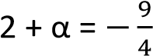
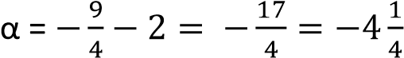
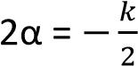
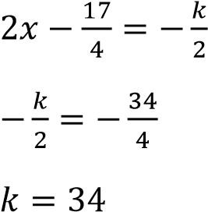

Example 3
The roots of the equation 2x² + 4x -1 = 0 are α and β. Find the value of α² + β². (05marks) 2x² + 4x -1 = 0
x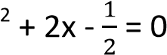
α + β = -2

α β = -
α² + β² = (α + β)² - 2 α β
= 4 – (-1) = 5

Example 4
The roots of the equation 2x² – 6x + 7 = 0 are α and β. Determine the
(a) values of (α – β)² and 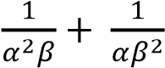
(12 marks) Solution
α+β = 3

αβ =
(α – β)² = α² + β² - 2αβ
But α² + β² = (α+β)² - 2αβ
=> (α – β)² =(α+β)² - 2αβ- 2αβ
= (α+β)² - 4αβ
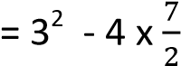
= -5
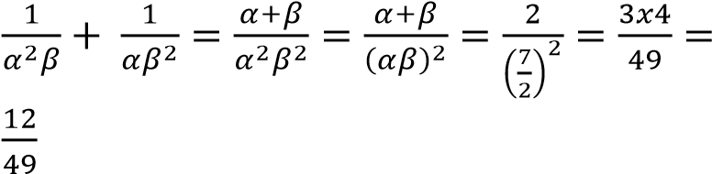
(b) Quadratic equation with integral coefficients whose roots (α – β)² and
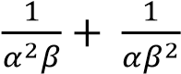(03marks)

Solution
Sum of root 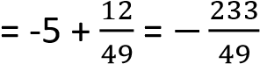
Product of roots =-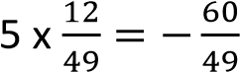
Equation
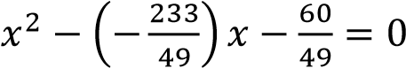
Hence equation is 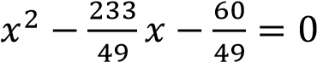

Example 5
Determine the possible values of α for which the equation
2x² + (α + 2)x + (α + 2) = 0 has equal roots
(05marks)
Solution
For equal roots b²= 4ac (α + 2)² = 4(2) (α + 2) α² + 4 α +4 = 8 α + 16 α² - 4 α – 12 = 0
(α -6)( α +2) = 0
Either α – 6 = 0, α = 6
Or α + 2 = 0, α = -2

Example 6
1. (a) Given that α and β are the root of the quadratic equation x² – 3mx + n² = 0, show that α+ β = 3m and αβ = n². Solution
(x – α)( x – β) = 0 x² – αx - x + αβ = 0 x² – (α + )x + αβ = 0
Comparing α+ β = 3m and αβ = n²
(b) If α and β are the root of the equation x²
– 9x + 4 = 0, find the;
(i) value of α² + β². (03marks)

Solution
From (α+β)² = α²+2αβ + β² α² + β² = (α+β)² - 2 αβ
= (9)² – 2x4
= 81 – 8
= 73
(ii) value of 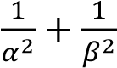.

Solution
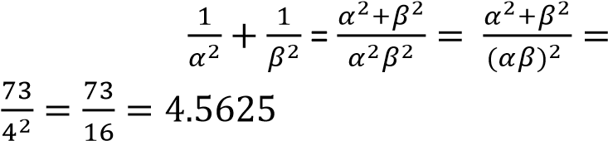
(iii) quadratic equation whose roots are 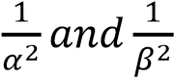.

Solution
Sum of the root, 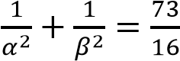
Product of the roots, 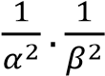 =
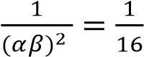
Hence quadratic equation
x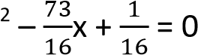
Exercise 1

(Answers are given in square brackets, [ ] at the end of each questions
- Given that the root of the equation x² + px + q = 0 are α and β, Form quadratic
equations with roots 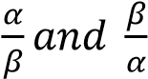
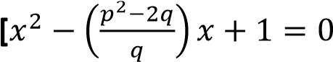
Or 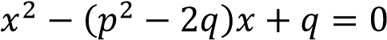 ]

- Given the equation x³ + x – 10 = 0.
- Show that x = 2 is a root of the equation
Let f(x) = x³ + x – 10 Substituting for x = 2 f(2) = 2³ + x -10 = 8 + 2 – 10
= 10 – 10 = 0
Hence x = 2 is a root of x³ + x –10 = 0
- Deduce the values of α + β and αβ where α and β are roots of the equation. Hence form a quadratic equation whose roots are α² and β².
⇨ x³ + x –10 = (x-2)(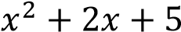)
Either x – 2 = 0
Or (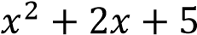) = 0
α + β = 2
αβ = 5
Sum of roots = α² + β² = 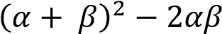
= (-2)² – 2(5) = 4 – 10 = -6

Product= 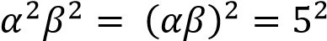 = 25
The equation become
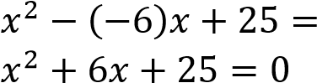

Solving quadratic equations
Quadratic equations may be solved by
- Factorization method
- Completing square method

(a) Factorization method It is used for quadratic equations that are
easy to factorise

Example 7
- 4x² + 7x + 3 = 0
Solution side work 4x(x + 1)+ 3(x + 1) = 0 Product = 4 x 3 = 12
  - + 1)(4x + 3) = 0 Sum = 7
Either x + 1 = 0; x = -1 Factor = (4, 3)
Or 4x + 3 = 0; x = -
- 2x² + 5x + 3 = 0
Solution side work
2x(x + 1)+ 3(x + 1) = 0 Product = 3 x 2 = 6
  - + 1)( 2x + 3) = 0 Sum = 5
Either x + 1 = 0; x = -1 Factors 3, 2
Or 2x + 3 = 0; x = 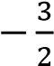
- x² + x – 20 = 0
Solution Side work
x(x – 4) + 5(x – 4) = 0 Product = -20 (x – 4)(x + 5) = 0 Sum = 1
Either x – 4 = 0; x = 4 Factors ( 5, - 4)
Or x + 5 = 0; x = -5
- 10x² + x – 3 = 0
Solution Side work
5x(2x -1) + 3(2x – 1) = 0 product 10 x – 3 = -30
(5x + 3)(2x – 1) = 0 sum = 1
Either 5x + 3 = 0; x = - Factors (6, -5)
Or 2x – 1 = 0; x =

(b) Method II: Completing squares approach
The idea is to create a perfect square on one side of the equation:
Given the equation ax²+ bx + c = 0
- Dividing the equation by and transposing the constant term to the RHS
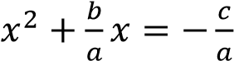
- Marking the LHS a perfect square, add a half the coefficient of x squared on both sides
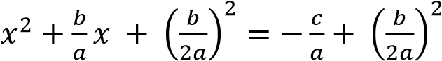
- Factorise the terms on the LHS
-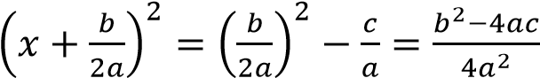
- Taking square root on both sides of the equation
-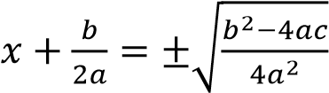
- Solving 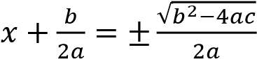
-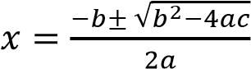
This is the general quadratic equation formula for finding the square root of any quadratic equation. This formula is locally known as bull dozer formula

Example 8
Solve the following equations by completing squares
- 2x² – x – 3 = 0 Solution 2x² – x – 3 = 0
  - 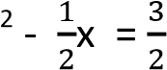
x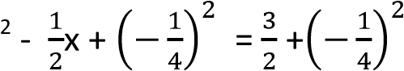
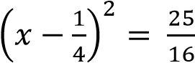
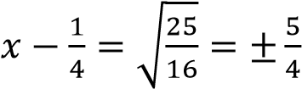
Either 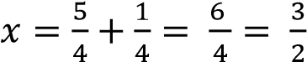
Or 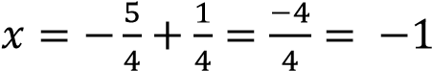
Hence x = -1 and x =
- 18x² + 7x – 1 = 0
Solution
18x² + 7x – 1 = 0
  - 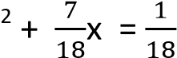
x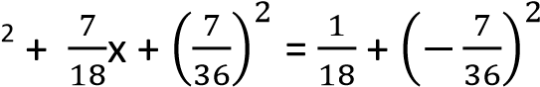
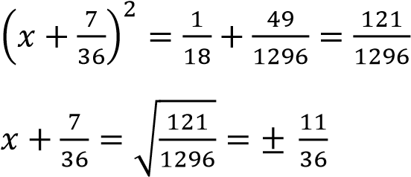
Either 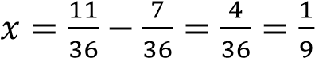
Or 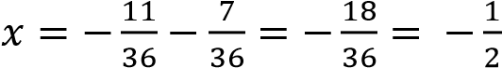
Hence x = or x =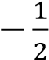
- 3x² + 7x + 2 = 0
Solution
3x² + 7x + 2 = 0
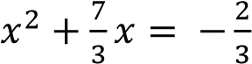
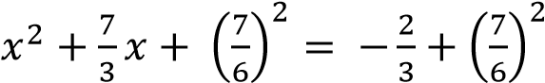
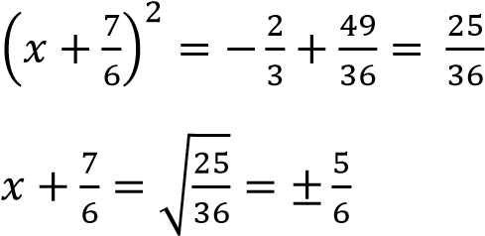
Either x =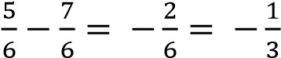
Or x =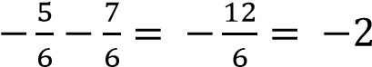
Hence x = -2 and x =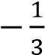

Example 8
Solve the following equations by using the quadratic formula
- 7x² – 5x – 2 = 0
Solution
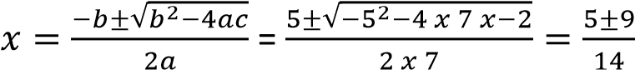
Either 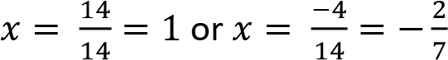
Hence 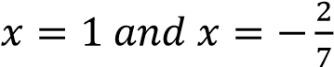
- 3x² – 7x – 6 = 0

√

=

√

Either 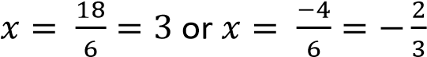
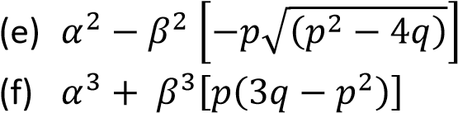
Revision exercise 2
[Answers are given in square brackets]
2. If the roots of the equation x² + 2x + 3 = 0
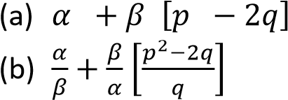
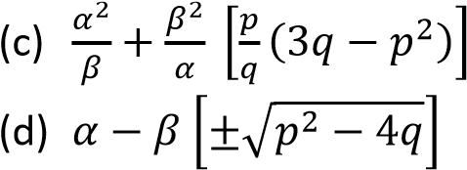
1. Given that the roots of the equation x² are α and β, form an equation whose roots + px + q = 0 are α and β, find the values of: are α² – β and β² – α. *x² + 2 = 0]

3. Given that the roots of the equation x² – 2x + 10 = 0 are α and β, form an equation
whose roots are

Hence 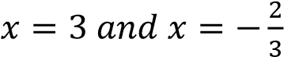
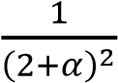 and 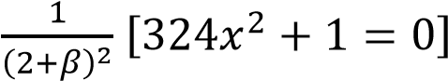

- If α and β are roots of the equation x²
– px + q = 0, find the equation whose roots
are 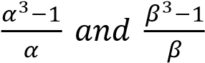
[qx² – (p²q – 2q²–p)x + (q³ – p³ + 3pq)+1=0]
- The roots of the equation 3x² – ax + 6b = 0 are α and β. Find the condition for one root to be
  - Twice the other [81b = a²)
  - The cube of the other
[a⁴ – 648(b – 1)b² – 18(4a² + 9)b = 0]
- By Factorization method solve the following quadratic equations
  - x² + 9x + 14 [x = -7, x= -2]

  - x² + 2x – 8 = 0 [ x = -4, x = 2)
  - 2x² + x – 10 = 0 [x= 2, x = -
  - 6x² – 19x + 10 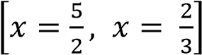
- Solve the following equations by completing squares
- 2x² + 5x + 3 = 0 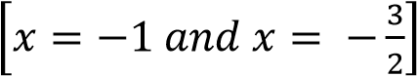
- x² + 9x + 20 = 0 [x = -5 and x = -4]
- x² + x – 20 = 0 [x = -5 and x = 4]
- x² – x – 20 = 0 [x = 4 and x = 5]
8. Solve the following equations using the quadratic formula (a) 2x2 + 5x + 3 = 0 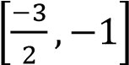
- x² + 9x + 20 [-5, -4]
- x² + x - 20 [-5, 4]

The roots of the equation 2x² + 4x -1 = 0 are α and β. Find the value of α² + β². (05marks)
2x² + 4x -1 = 0
x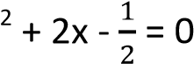
α + β = -2 α β = -
α² + β² = (α + β)² - 2 α β
= 4 – (-1) = 5

The roots of the equation 2x² – 6x + 7 = 0 are α and β. Determine the
- values of (α – β)² and 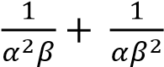 (12 marks)
Solution α+β = 3
αβ =
(α – β)² = α² + β² - 2αβ
But α² + β² = (α+β)² - 2αβ
=> (α – β)² =(α+β)² - 2αβ- 2αβ
= (α+β)² - 4αβ
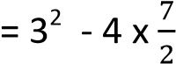
= -5
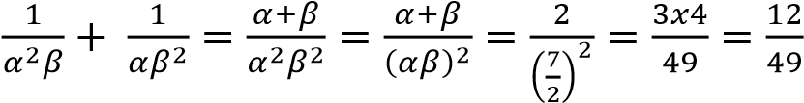
- Quadratic equation with integral coefficients whose roots (α – β)² and 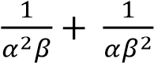 (03marks)
Sum of root = -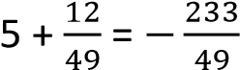
Product of roots =-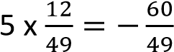
Equation
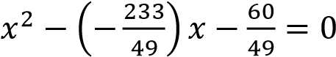
Hence equation is 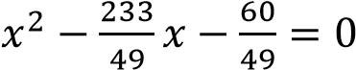
2. (a) Given that α and β are the root of the quadratic equation x² – 3mx + n² = 0, show that α+ β = 3m and αβ = n². (06 marks) Solution
(x – α)( x – β) = 0 x² – αx - x + αβ = 0 x² – (α + )x + αβ = 0
Comparing
α+ β = 3m and αβ = n²
(b) If α and β are the root of the equation x² – 9x + 4 = 0, find the;
- value of α² + β². (03marks)
Solution
From (α+β)² = α²+2αβ + β² α² + β² = (α+β)² - 2 αβ
= (9)² – 2x4
= 81 – 8
= 73
- value of 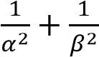. (03marks)

Solution
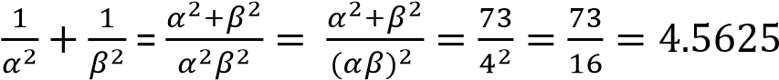

(iii) quadratic equation whose roots are 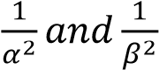. (03marks)

Solution
Sum of the root, 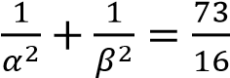
Product of the roots, 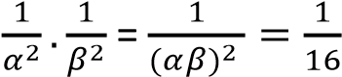
Hence quadratic equation
x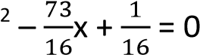

TOPIC 3/3: Descriptive Statistics
Competency: The learner analyses statistical measures to effectively interpret data from real life contexts enabling them to make informed decisions.
Statistics
This a branch of mathematics dealing with collection, presentation, analysis and interpretation of data

Types of data
- Discrete data
Its information collected by counting and usually takes integral values that do not lie within a given range
- Continuous data
It is information that takes values within a given range

Discrete or ungrouped data
Terms Used
- Mean or average of a sample
It is denoted by and defined as 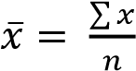; where x is the variable given and n is the number of variable
If assumed mean (working mean) a is given then
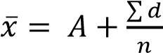; where d = x – A
If the frequency, f, s given then 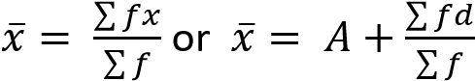
- Variance or Var(X) 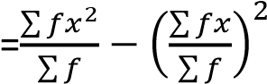
- Standard deviation 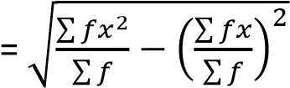
- Mode
This is the value of the distribution that appears most
- Median
This is the middle value of the distribution obtained after the values have been arranged either in ascending of descending order.
Median = 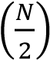 value.
Note that the values must be arranged in ascending or descending order
- Range
It is the difference between the largest value and the smallest value.

(vii) Quartiles
A quartile is a value that divides given values into four equal parts q₁ is the lower quartile and is defined by
q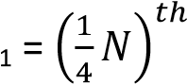value where N is the sum of all the variables
q₃ is the upper quartile and is defined by
q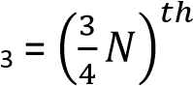value where N is the sum of all the variables
Note that the values must be arranged in ascending or descending order

(viii) Percentiles
A percentile is a value that divides given values into 100 pats.
P₁₀ is the 10th percentile and is defined as
P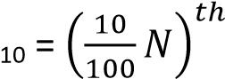value where N is the sum of all the variables
P₉₀ is the 10th percentile and is defined as
P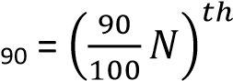value where N is the sum of all the variables
Note that the values must be arranged in ascending or descending order (ix) Deciles
A decile is a value that divides given values into 10 pats.
D₅ is the 5th decile and is defined as
D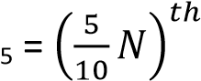value where N is the sum of all the variables
Note that the values must be arranged in ascending or descending order

Example 1
Given the following sets of values
2, 1, 3, 4, 5, 6, 7, 8, 9, 10, 3, 4, 6, 8, 9, 6, 3, 2
- Form a frequency table of ungrouped data
x | f | fx | cf | x² | fx²
1  2  3  4  5  6  7  8  9  10 | 1  2  3  2  1  4  2  2  2  1 | 1  4  9  8  5  24  14  16  18  10 | 1  3  6  8  9  13  15  17  19  20 | 1  4  9  16  25  36  49  64  81  100 | 1  8  27  32  25  144  98  128  162  100
 | 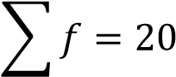 | 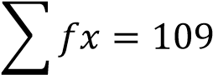 |  |  | 725

- Use the table to find the mean and mode
  - Mean, 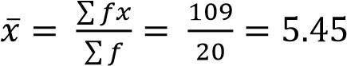
  - Standard deviation = 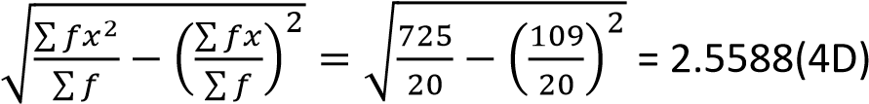
  - Mode = 6 (the value that appear most
  - Find the median value
Median = 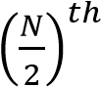value = 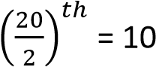th value from cumulative frequency, cf ; median = 6
  - Range = 10 – 1 = 9
  - Lower quartile, q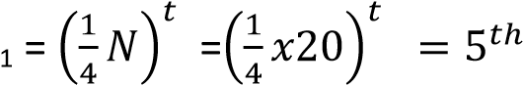 value, from cf, q₁ = 3
  - Lower quartile, q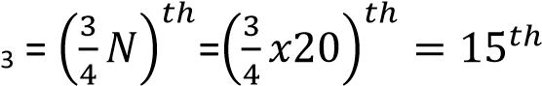 value, from cf, q₃ = 7
  - Tenth percentile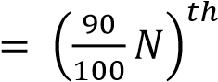value where N is the sum of all the variables

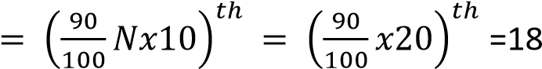
th
value
From cf,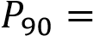9

Example 2
The ages of eight students in a class are: 12, 13, 14, 15, 12, 17, 12, 13, 16, 12.
Find the;
- Form a frequency table of ungrouped data
x | f | cf | fx | x² | fx²
12 | 4 | 4 | 48 | 144 | 576
13 | 2 | 6 | 26 | 169 | 338
14 | 1 | 7 | 14 | 196 | 196
15 | 1 | 8 | 15 | 225 | 225
16 | 1 | 9 | 16 | 256 | 256
17 | 1 | 10 | 17 | 289 | 289
 | ∑f =10 |  | ∑fx = 136 |  | ∑fx²=1,880
- Use the table to find
  - mean age
mean = 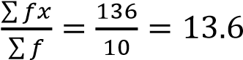
  - variance
Var (X) = 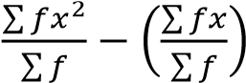
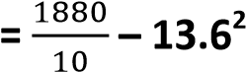

= 3.04
  - Standard deviation = 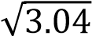 =1.7436(4D)

  - Mode = 12 (most frequent figure)

  - Median = 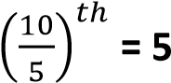^{th} value = 13

  - Range = 17 – 12 = 5
  - Lower quartile, q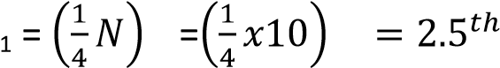 value, from cf, q₁ = 12
  - Lower quartile, q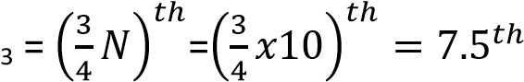 value, from cf, q₃ = 15
  - Tenth percentile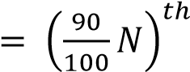value where N is the sum of all the variables

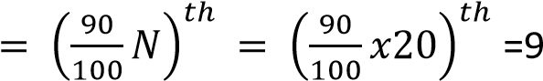^{th} value
From cf,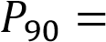16
Example 3
The frequency distribution table shows the marks of some student from a certain school
x | 45 | 63 | 65 | 66 | 70 | 72 | 75 | 80 | 88
f | 3 | 5 | 6 | 4 | 6 | 2 | 1 | 2 | 1
Calculate standard deviation

Solution
x | f | fx | fx²
45 | 3 | 135 | 6075
63 | 5 | 315 | 19845
65 | 6 | 390 | 25350
66 | 4 | 264 | 17424
70 | 6 | 420 | 29400
72 | 2 | 144 | 10368
75 | 1 | 75 | 5625
80 | 2 | 160 | 12800
88 | 1 | 88 | 7744
 | 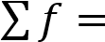30 | 1991 | 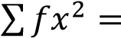134631
Using assumed mean to get variance and standard deviation
Var (X) = 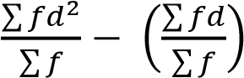
s.d =
√
∑

∑

(
∑

∑

)

S.d =
√
∑

∑

(
∑

∑

)

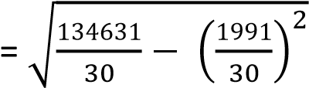
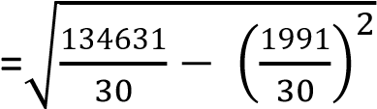
=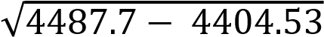
= 9.12

Revision exercise 1
- The data below represents the length of leaves in cm: 4.5 4.4, 6.2, 9.4, 8.2, 12.6, 10.0, 8.8, 3.8 and
13.6. find the;
    - Mean
    - Standard deviation
- The concentration in m per litre of a trace element in 7 randomly chosen samples of water from spring wells were: 240.8, 237.3, 236.6, 2333.9 and 232.5. Determine the mean and the variance of the concentration of the trace elements per litre.

- The table below shows the length of flowers from a certain plant to the nearest 0.5cm.
Length (cm) | 7.5 | 8.0 | 8.5 | 9.0 | 9.5 | 10.0 | 10.5 | 11.0
Number of flowers | 4 | 9 | 11 | 8 | 10 | 7 | 2 | 3
Find the:
    - Mean
    - Mode
    - The median
    - Standard deviation
- The marks scored by 11 students in a test are:52, 61, 78, 49, 47, 79, 54, 58, 62, 73, 72 Find;
    - Median,
    - Mean,
    - Interquartile range
    - Semi-quartile range
- The frequency distribution table shows the heights of some students at a certain school
Height | 154 | 155 | 160 | 164 | 171 | 180
Frequency | 4 | 6 | 8 | 5 | 4 | 3
Determine the variance and standard deviation of the data using a working mean of 160
- The table below shows the marks obtained by 20 students in a mathematics test marked out of 20
Marks | 10 | 11 | 12 | 13 | 14 | 15 | 16 | 17 | 18 | 19 | 20
Number of students | 1 | 2 | 2 | 2 | 2 | 4 | 2 | 1 | 2 | 1 | 1
Find:
    - Mean mark
    - Standard deviation (c) 60th percentile
(d) Interquartile range
- Given the following scores
8, 6, 8, 9, 10, 6, 4, 5, 6, 4, 4, 6, 8, 7, 10, 8, 6, 11, 12, 8
    - Form a frequency distribution table of ungrouped data.
    - Find the standard deviation
    - Calculate semi-quartile range
    - Determine the range of 45th and 90th percentile.

Solutions to revision exercise 1
- The data below represents the length of leaves in cm: 4.5 4.4, 6.2, 9.4, 8.2, 12.6, 10.0, 8.8, 3.8 and
13.6. find the;
    - Mean
    - Standard deviation
Solution
x | x²
4.5 | 20.25
4.4 | 19.36
6.2 | 38.44
9.2 | 84.64
8.2 | 67.24
12.0 | 144
10.0 | 100
8.8 | 77.44
3.8 | 14.44
13.6 | 184.96
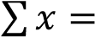80.7 | 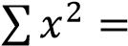750.77

      - Mean, 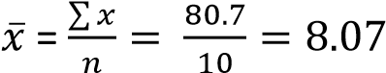
      - s.d =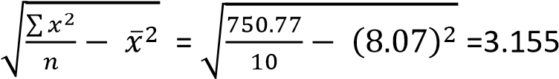
- The concentration in m per litre of a trace element in 7 randomly chosen samples of water from spring wells were: 240.8, 237.3, 236.6, 2333.9 and 232.5. Determine the mean and the variance of the concentration of the trace elements per litre.
Solution
 |  |  |   Mean,  𝑥  ̅  =  ∑  𝑥  𝑛  Var(x) =  ∑  𝑥  𝑛  𝑥  ̅  =  55,702.5  =  –  55,696  = 6.5
  x | x²
  240.8 | 57984.64
  237.3 | 56311.29
  236.7 | 56026.89
234.2 | 54849.64
236.6 | 55979.56
233.9 | 54709.21
232.5 | 54056.25
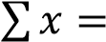1652 | 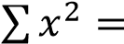389917.5

- The table below shows the length of flowers from a certain plant to the nearest 0.5cm.
Length (cm) | 7.5 | 8.0 | 8.5 | 9.0 | 9.5 | 10.0 | 10.5 | 11.0
Number of flowers | 4 | 9 | 11 | 8 | 10 | 7 | 2 | 3
Find the:
    - Mean
    - Mode
    - The median
    - Standard deviation
Solution
 |   (  a)Mean =  ∑  𝑓𝑥  ∑  𝑓  (  b) mode  = 8.5  c) Median =  (  (  )  𝑡  value  27  =  th  value  From cf the 27  th  value = 9.0
  x | f | fx | fx² | cf
  7.5 | 4 | 30 | 225 | 4
  8.0 | 9 | 72 | 576 | 13
  8.5 | 11 | 93.5 | 794.75 | 24
  9.0 | 8 | 72 | 648 | 32
  9.5 | 10 | 95 | 902.5 | 42
  10.0 | 7 | 70 | 700 | 49
  10.5 | 2 | 21 | 220.5 | 51
  11.0 | 3 | 33 | 363 | 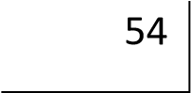
   | 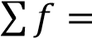54 | 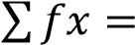486.5 | 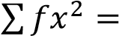4429.75

(d) s.d = 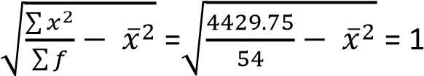
- The marks scored by 11 students in a test are:52, 61, 78, 49, 47, 79, 54, 58, 62, 73, 72 Find;
(a) Median
Arrange values in ascending order
47, 49, 52, 54, 58, 61, 62, 72,73,78,79
      - Median =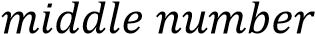 = 6th value = 61
      - Mean,
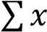 = 52+ 61+78 + 49 + 47 + 79 + 54 + 58 + 62 + 73 + 72 =685
Mean = 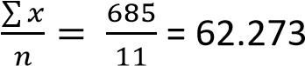
(b) Interquartile range
q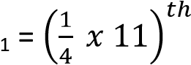value = 2.75th value = 52 q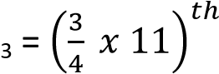value = 8.25th value = 73
Interquartile range = 73 -52 = 21

(c) Semi-quartile range 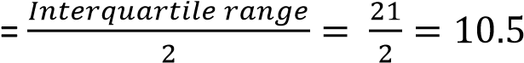

- The frequency distribution table shows the heights of some students at a certain school
Height | 154 | 155 | 160 | 164 | 171 | 180
Frequency | 4 | 6 | 8 | 5 | 4 | 3
Determine the variance and standard deviation of the data using a working mean of 160 Solution
 |   Var (X) =  ∑  𝑓𝑑  ∑  𝑓  (  ∑  𝑓𝑑  ∑  𝑓  )  =  (  )  = 63.156  s.d =  𝑉𝑎𝑟  (  𝑥  )  =  √  =7.95
  x |  | f | d = x - A | fd | fd²
   | 154 | 4 | -6 | -24 | 144
   | 155 | 6 | -5 | -30 | 150
   | 160 | 8 | 0 | 0 | 0
   | 164 | 5 | 4 | 20 | 80
   | 171 | 4 | 11 | 44 | 484
   | 180 | 3 | 20 | 60 | 1200
   |  | 30 |  | 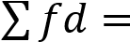70 | 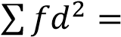2058

- The table below shows the marks obtained by 20 students in a mathematics test marked out of 20
Marks | 10 | 11 | 12 | 13 | 14 | 15 | 16 | 17 | 18 | 19 | 20
Number of students | 1 | 2 | 2 | 2 | 2 | 4 | 2 | 1 | 2 | 1 | 1
Find:
    - Mean mark
    - Standard deviation (c) 60th percentile
(d) Interquartile range
Solution
 |   (  a  )  s.d =  √  ∑  𝑓𝑥  ∑  𝑓  (  ∑  𝑓𝑥  ∑  𝑓  )  =  √  (  )  = 2.722  )  b  (  60  th  percentile  =  (  𝑥  )  𝑡  value  12  =  th  value from cf =15
  x | f | cf | fx | fx²
  10 | 1 | 1 | 10 | 100
  11 | 2 | 3 | 22 | 242
  12 | 2 | 5 | 24 | 288
  13 | 2 | 7 | 26 | 338
  14 | 2 | 9 | 28 | 392
  15 | 4 | 13 | 60 | 900
  16 | 2 | 15 | 32 | 512
  17 | 1 | 16 | 17 | 289
  18 | 2 | 18 | 36 | 648
  19 | 1 | 19 | 19 | 361
  20 | 1 | 20 | 20 | 400
   | 20 |  | 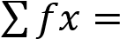294 | 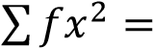4470
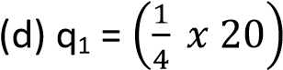
value = 5th value from cf = 12
Q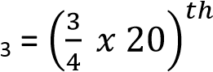value = 15th value from cf = 16
Interquartile range = 16 -12 = 4

- Given the following scores
8, 6, 8, 9, 10, 6, 4, 5, 6, 4, 4, 6, 8, 7, 10, 8, 6, 11, 12, 8
    - Form a frequency distribution table of ungrouped data.
    - Find the standard deviation
    - Calculate semi-quartile range
    - Determine the range of 45th and 90th percentile.
Solution
 |   (  b  )  s.d =  √  ∑  𝑓𝑑  ∑  𝑓  (  ∑  𝑓𝑑  ∑  𝑓  )  =  √  (  )  =2.26  )  c  (  q  1  =  (  𝑥  )  𝑡  value  5  =  th  value  from cf =  6  q  3  =  (  𝑥  )  𝑡  value  15  =  th  value  ,  from cf =  8
  x | f | cf |  | fx | fx²
  4 | 3 |  | 3 | 12 | 48
  5 | 1 |  | 4 | 5 | 25
  6 | 5 |  | 9 | 30 | 180
  7 | 1 |  | 11 | 7 | 49
  8 | 5 |  | 16 | 40 | 320
  9 | 1 |  | 17 | 9 | 81
  10 | 2 |  | 19 | 20 | 200
  11 | 1 |  | 20 | 11 | 121
  12 | 1 |  | 21 | 12 | 144
   | 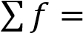20 |  |  | 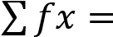146 | 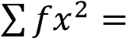1168
Semi-interquartile range = 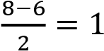
(d) 45th percentile = 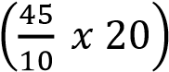 value = 9th value from cf = 6
90th percentile = 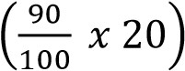 value = 18th value from cf = 10
The range between the 90th percentile and 45th percentile = 10 – 6 = 4

Continuous or grouped data.
This is data whose scores or values are said to be continuous and take interval values
Example
Class | 20 – 29 | 30 – 39 | 40 – 49 | 50 – 59 | 60 – 69 | 70 – 79 | 80 - 89
Number of students | 4 | 5 | 7 | 3 | 6 | 4 | 1

Terms used
- Class: these are limits of distribution. In the table above, the classes are: (20 – 29), (30 – 39), (40 – 49), (50 – 59), (60 – 69), (70 – 79), (80 – 89).
- Class mark or mark (x)
- Frequency (f) = number of items in a class
This is the mid-point value of the class. It is normally denoted by x. in the table above, the class marks are 24.5, 34.5, 44.5 …..
- Class boundary
These are continuous class limits. In the above table the first class boundary is (20-0.5) – (29
+0.5). In this case, the lower class boundary is 19.5 and upper class boundary is 29.5
For class interval 2.0 – 2.9, the class boundary is (2.0 -0.05) – (2.9 + 0.05) = 1.952.95.
- Class width or class interval
This is the width of each class boundary.
It is given by;
Class width = upper class boundary – lower class boundary
In the table above, class width = 29.5 – 19.5 = 10
- Mean, 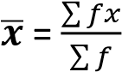
- Variance (Var(X) = 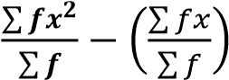
- Standard deviation =

(

)

√
∑

∑

(
∑

∑

)

- Median of grouped data
Median of grouped data is defined by
Median = L_{b} 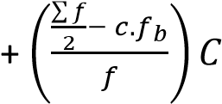
Where L_{b} = lower class boundary of the median class
C= class width of the median class

(j) Mode of grouped data
Mode of grouped data with equal class width is defined as
Mode = Lb 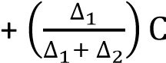
Where
Lb = lower class boundary of modal class
C = Class width of the modal class
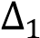 = Modal frequency (pre-modal frequency)
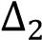 = Modal frequency (post modal frequency)

(k) Median of grouped data
Median of grouped data is defined by
Median = L_{b} 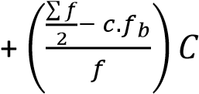
Where L_{b} = lower class boundary of the median class C= class width of the median class f = frequency of the median class
c.f_{b}= cumulative frequency before that of the median class

(l) Histogram
This is a graph consisting of vertical bars. It is a graph of frequency against class boundary. The area of the bar is equal to the frequency. Histogram is used to obtain the mode

- Percentile
This a value that divides a given distribution into 100 equal parts The 60th percentile for instance is defined as
P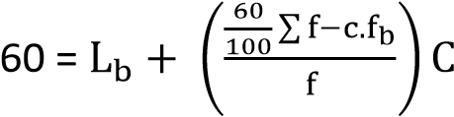
Where
Lb = lower class boundary of the 60th class
C= class width
F = frequency of the 60th class
c.f_{b} = cumulative frequency before that one of the 60th class
- Quartiles
This a value that divides a given distribution into 4 equal parts

The lower quartile denoted q1 for instance is defined as
q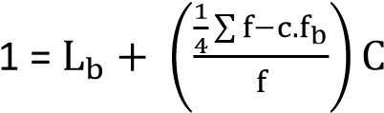
Where
L_{b} = lower class boundary of the q₁ class
C= class width
f = frequency of the q₁ class
c.f_{b} = cumulative frequency before that one of the q₁ class The upper quartile denoted q₃ for instance is defined as
q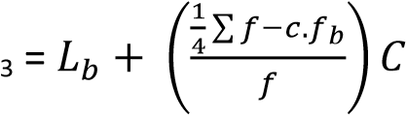
Where
L_{b} = lower class boundary of the q₃ class
C= class width
f = frequency of the q₃ class
c.f_{b} = cumulative frequency before that one of the q₃ class
Interquartile range = q₃ –q₁
Semi-interquartile range =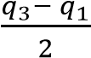

Example 4
The table below shows the weight of 250 students at The Science Foundation College
Weight (kg) | 44.0 –  47.9 | 48.0 –  51.9 | 52.0 –  55.9 | 56.0 –  59.9 | 60.0 –  63.9 | 64.0 –  67.9 | 68.0 –  71.9 | 72.0 –  75.9
Frequency | 3 | 17 | 50 | 45 | 46 | 57 | 23 | 9
Find
    - Average weight
    - Standard deviation
    - Median weight
    - Modal weight
    - Draw an Ogive and use it to find
      - Upper quartile
      - And 10th percentile
(f) Construct a histogram and use it to determine the mode
Solution
Class | Class boundary | x | f | fx | fx² | cf
44.0 - 47.9 | 43.95 - 47.95 | 45.95 | 3 | 137.85 | 413.55 | 3
48.0 - 51.9 | 47.95 - 51.95 | 49.95 | 17 | 849.15 | 14435.55 | 20
52.0 - 55.9 | 51.95 - 55.95 | 53.95 | 50 | 2697.5 | 134875 | 70
56.0 -59.9 | 55.95 - 59.95 | 57.95 | 45 | 2607.75 | 117348.8 | 115
60.0 - 63.9 | 59.95 - 63.95 | 61.95 | 46 | 2849.7 | 131086.2 | 161
64.0 - 67.9 | 63.95 - 67.95 | 65.95 | 57 | 3759.15 | 214271.6 | 218
68.0 - 71.9 | 67.95 - 71.95 | 69.95 | 23 | 1608.85 | 37003.55 | 241
72.0 - 75.9 | 71.95 - 75.95 | 73.95 | 9 | 665.55 | 5989.95 | 250
 |  |  | 250 | 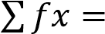15175.5 | 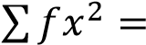655424.1
  - Mean, ̅ ∑
∑
  - Standard
  - Median = L_{b} 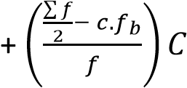
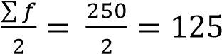
Median class boundary is 59.95 - 63.95, f = 46 and C = 4
Median = 59.95 + 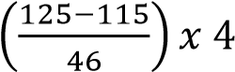 = 60.82kg
  - Modal class boundary is 63.95 – 67.95, since 57 is the highest frequency and C = 4
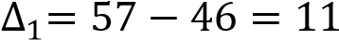 and 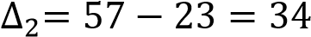
  - Draw an Ogive and use it to find
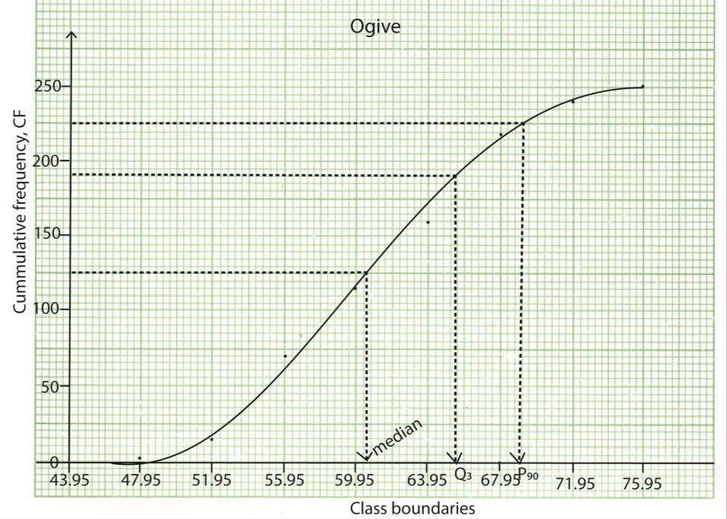
    - Upper quartile 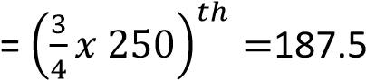^{th} value, from the graph q₃ = 65.55
    - Median 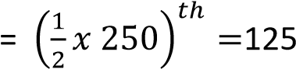^{th} value, from the graph, median = 65.55
    - 10th percentile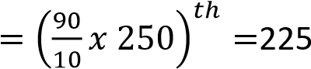^{th} value, from the graph, P90 = 69.15
(f) Construct a histogram and use it to determine the mode
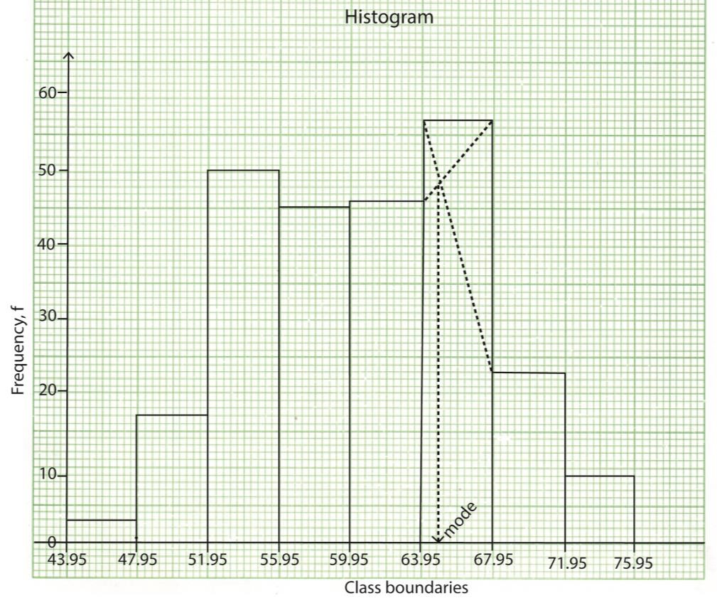
From the graph, the mode =63.95 + 0.8= 64.75

Example 5
The table below shows the number of students and the mark scored in a test.
MARKS | NUMBER OF STUDENTS
0 – 4 | 10
5 – 9 | 7
10 – 14 | 5
15 – 19 | 3
20 – 24 | 7
25 – 29 | 11
30 – 34 | 37
35 – 39 | 20
(a) (i) Draw a cumulative frequency curve (Ogive) for data
MARKS | Class boundaries | NUMBER OF  STUDENTS (f) | Cf | x | fx | fx²
0– 4 | 0 – 4.5 | 10 | 10 | 2 | 20 | 40
5 – 9 | 4.5 – 9.5 | 7 | 17 | 7 | 49 | 343
10 – 14 | 9.5 – 14.5 | 5 | 22 | 12 | 60 | 720
15 – 19 | 14.5 – 19.5 | 3 | 25 | 17 | 51 | 867
20 – 24 | 19.5 – 24.5 | 7 | 32 | 22 | 154 | 3388
25 – 29 | 24.5 – 29.5 | 11 | 43 | 27 | 297 | 019
30 – 34 | 29.5 – 34.5 | 37 | 80 | 32 | 1184 | 37888
35 – 39 | 34.5 – 39.5 | 20 | 100 | 23 | 740 | 27380
 |  | 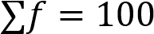 |  |  | ∑fx =2555 | ∑fx²=78645

- Use the Ogive to estimate the median mark (06marks)
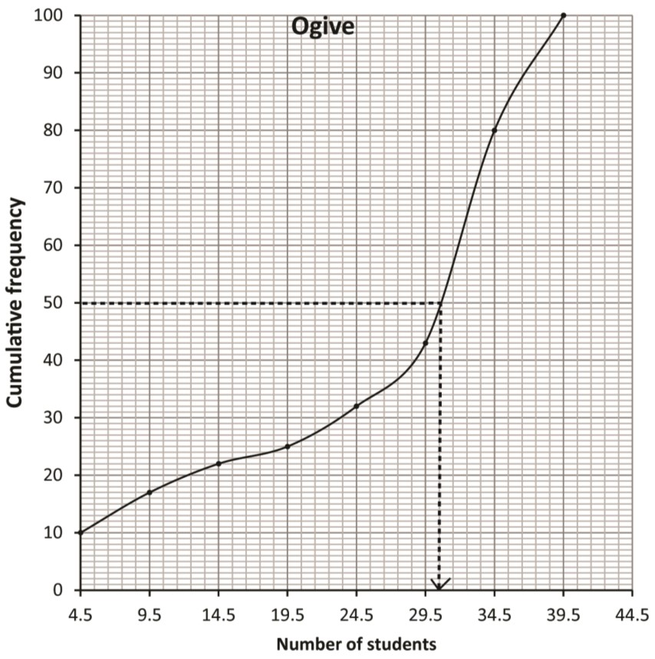
Note that Cf is plotted against the upper limit of the class

Median =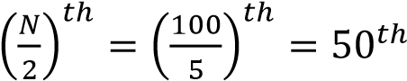 value= 30.5
(b) Calculate the
      - Mean mark
Mean = 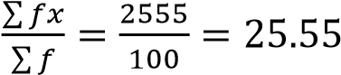
      - Standard deviation (09 marks)
S.d = 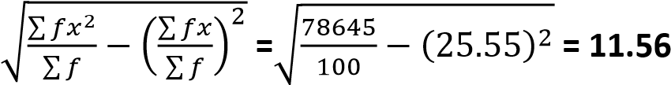
Example 6
The frequency distribution table below shows the marks of 50 students score in a test
Marks | Number of Students
50 – 52 | 3
53 – 55 | 16
56 – 58 | 14
59 – 61 | 13
62 – 64 | 2
65 – 67 | 2
(a) Calculate the:
Solution
Marks | Class boundaries | Number of  Students  (f) | fx | Fx² | CF
50 – 52 | 49.5 – 52.5 | 3 | 153 | 7803 | 3
53 – 55 | 52.5 – 55.5 | 16 | 864 | 46656 | 19
56 – 58 | 55.5 – 58.5 | 14 | 798 | 45486 | 33
59 – 61 | 58.5 – 61.5 | 13 | 780 | 46800 | 46
62 – 64 | 62.5 – 64.5 | 2 | 126 | 7938 | 48
65 – 67 | 64.5 - 67.5 | 2 | 132 | 712 | 50
 |  | 50 | 2853 | 163395

      - Mean mark (04 marks)
Solution
Mean,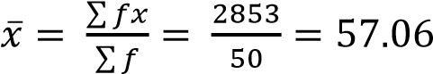
      - Standard deviation. (05 marks)

s.d =
√
∑

∑

̅

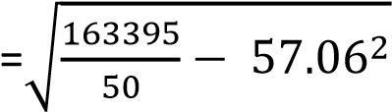
= 12.06

(b) (i) Plot a cumulative frequency curve (Ogive) for the given data. (04 marks)
Note that CF is plotted against the upper limit of each class
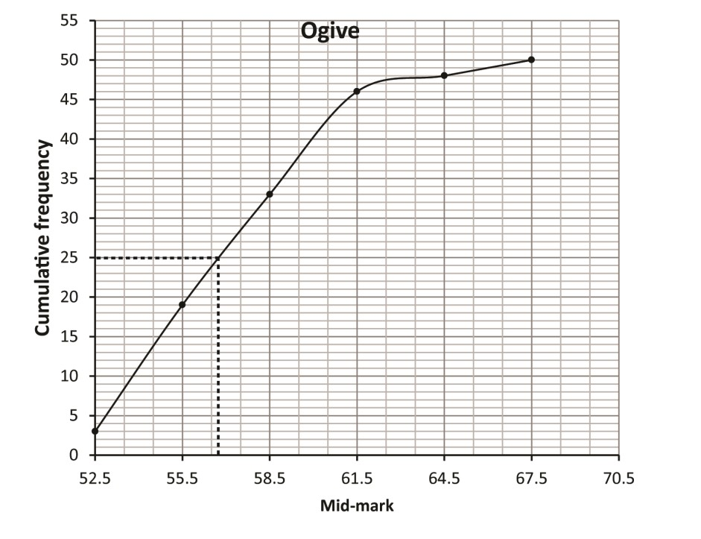
- Use the Ogive to estimate the median mark. (02 marks)
56.5
Example 7
The table below shows the age in years of mothers at the time they had their first child.
Age in years | 15 - | 20 - | 25 - | 30 - | 35 - | 40 - 45
Number of mothers | 2 | 14 | 29 | 43 | 33 | 9
Calculate the modal age of the mothers. (05 marks)
Using the formula
Mode = Li + 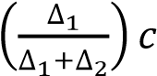
Modal class (30 – 35)
∆1 = 43 - 29 = 14
∆2 = 43 – 33 = 10
Li = 30, Cc = 5
Mode = 30 + 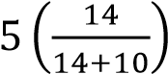= 32.92 (2D)
Example 8
The table below shows a frequency distribution of marks scored by s5 students in a test.
Marks | 10 - | 20 - | 30 - | 40 - | 50 - | 60 - | 70 - | 80 -  ≤90
Number of students | 2 | 6 | 12 | 15 | 10 | 6 | 3 | 1
- Draw a histogram for the data and use it to estimate the modal mark. (05marks)
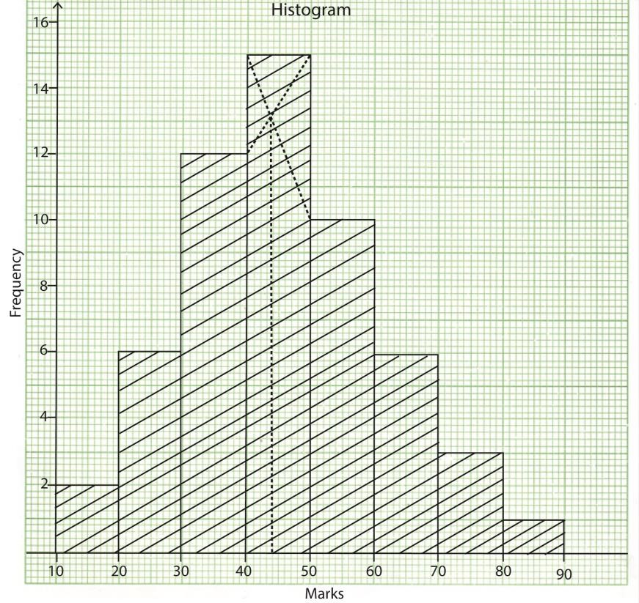
From the graph modal mark is 44

- Calculate the
Marks | x | f | fx | fx²
10 - 20 | 15 | 2 | 30 | 450
20 - 30 | 25 | 6 | 150 | 3750
30 - 40 | 35 | 12 | 420 | 14700
40 - 50 | 45 | 15 | 675 | 30375
50 - 60 | 55 | 10 | 550 | 30250
60 - 70 | 65 | 6 | 390 | 25350
70 - 80 | 75 | 3 | 225 | 16875
80 - 90 | 85 | 1 | 85 | 7225
 |  | ∑f = 55 | ∑fx=2525 | ∑fx²=128975
    - mean mark
Means, 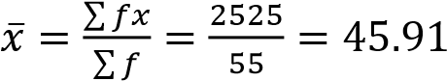
    - standard deviation (10marks)
S.D = 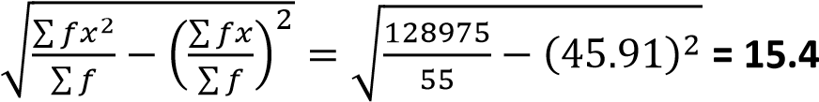

Example 9
The table below shows the weights in kg of 50 cattle on a farm
60 | 81 | 76 | 68 | 84 | 112 | 76 | 102 | 86 | 67
65 | 98 | 107 | 110 | 72 | 99 | 87 | 92 | 76 | 77
94 | 102 | 87 | 86 | 73 | 118 | 98 | 120 | 62 | 87
65 | 92 | 104 | 116 | 91 | 93 | 78 | 122 | 102 | 92
80 | 111 | 73 | 120 | 106 | 123 | 94 | 109 | 80 | 96

- Form a grouped frequency table for the data with classes of equal intervals, starting with the class 60 – 69. (06 marks)
Classes | Class boundaries | Frequency, f | Cumulative frequency, CF
60 – 69 | 59.5 – 69.5 | 6 | 6
70 – 79 | 69.5 – 79.5 | 8 | 14
80 – 89 | 79.5 – 89.5 | 9 | 23
90 – 99 | 89.5 – 99.5 | 11 | 34
100 – 109 | 99.5 – 109.5 | 7 | 41
110 – 119 | 109.5 – 119.5 | 5 | 46
120 – 129 | 119.5 – 129.5 | 4 | 50
- Draw a cumulative frequency curve (Ogive) for the given data. (04 marks)
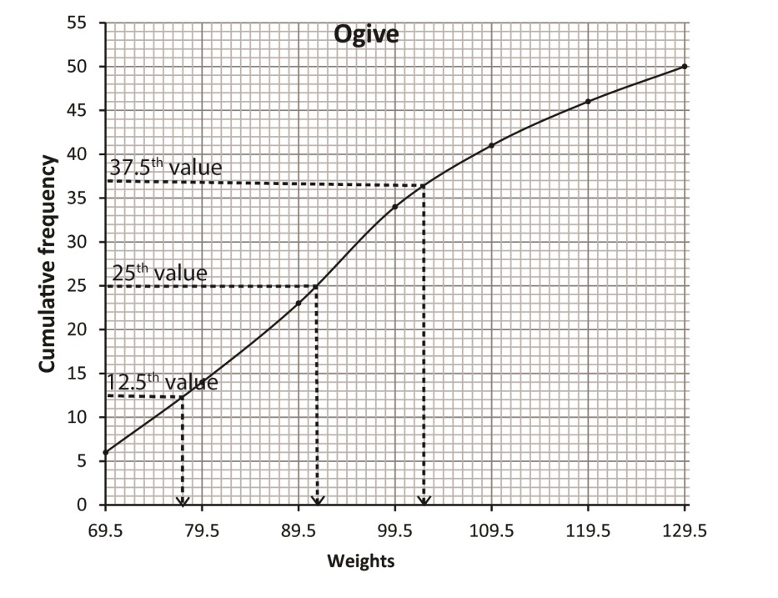
Note that CF is plotted against the upper limit value of the class
- Use your Ogive to estimate the;
      - lower and upper quartile
Lower quartile, q
      - median weight
Median =
      - number of cattle which weigh 118kg and above. (05 marks)
Upper quartile, q
Example 10
Given the data below
Marks (x) | 10-19 | 20-24 | 25-34 | 35-39 | 40-54 | 55-64 | 65-79
Frequency (f) | 4 | 6 | 7 | 3 | 8 | 6 | 6
Find the mode
Solution
 |   Mode = L  b  +  𝑓  𝑑  𝑓  𝑑  𝑓  𝑑  𝐶  =  19.5 +  (  (  )  (  )  )  𝑥  = 22.58
  Class boundary | Class width |  | f | Frequency density
  9.5 - 19.5 |  | 10 | 4 | 0.4
  19.5 - 24.5 |  | 5 | 6 | 1.2
  24.5 - 34.5 |  | 10 | 7 | 0.7
  34.5 - 39.5 |  | 5 | 3 | 0.6
  39.5 - 54.5 |  | 15 | 8 | 0.53
  54.5 - 64.5 |  | 10 | 6 | 0.6
  64.5 - 79.5 |  | 15 | 6 | 0.4
   |  |  | 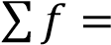40

Example 11
The table shows the weights (kg) of 150 patients who visited a certain health centre.
Weight (kg) | 0 – 9 | 10 – 19 | 20 – 29 | 30 – 39 | 40 – 49 | 50 – 59 | 60 - 69
Frequency (f | 30 | 16 | 24 | 32 | 28 | 12 | 8
Calculate
    - Mean
    - Mode
    - Median
Class | Class boundary | class mark (x) | f | fx | cf
0 - 9 | 0 - 9.5 | 4.5 | 30 | 135 | 30
10 - 19 | 9.5 - 19.5 | 14.5 | 16 | 232 | 46
20 - 29 | 19.5 - 29.5 | 24.5 | 24 | 588 | 70
30 - 39 | 29.5 -39.5 | 34.5 | 32 | 1104 | 102
40 - 49 | 39.5 - 49.5 | 44.5 | 28 | 1246 | 130
50 - 59 | 49.5 - 59.5 | 54.5 | 12 | 654 | 142
60 - 69 | 59.5 - 69.5 | 64.5 | 8 | 516 | 150
 |  |  | 150 | 4475
    - Mean ̅ ∑ = 29.83kg
∑
    - Mode = L_{b} 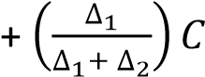
Modal class boundary is 29.5 – 39.5, since 32 is the highest frequency and C = 10
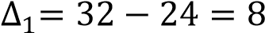 and 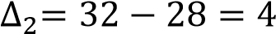
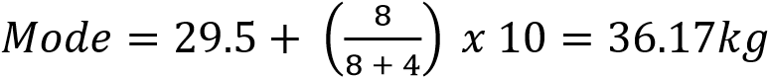
    - Median = L_{b} 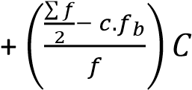
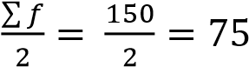
Median class boundary is 29.5 -39.5, f = 32 and C = 10
Median = 29.5 + 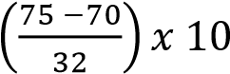 = 30.06kg

Example 12
The table below shows the number of crimes committed by students
Number of crimes | 5-<10 | 10-<20 | 20-<30 | 30-<50 | 50-<100
Number of students | 10 | 15 | 25 | 40 | 26
Calculate the variance and standard deviation for the number of crimes committed
Solution
Number of crime | x | f | fx | fx²
5-<10 | 7.5 | 10 | 75 | 562.5
10-<20 | 15 | 15 | 225 | 3375
20-<30 | 25 | 25 | 625 | 15625
30-<50 | 40 | 40 | 1600 | 64000
50-<100 | 75 | 25 | 1875 | 140625
 |  | 115 | 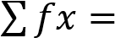4400 | 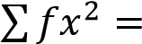224187.5
∑ ∑ Var(x) = ( ) ( )
∑ ∑
s.d = 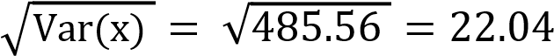

Example 13
The table below shows the weight of 250 students at a certain day school
Weight  (kg) | 44.0 –  47.9 | 48.0 –  51.9 | 52.0 –  55.9 | 56.0 –  59.9 | 60.0 –  63.9 | 64.0 –  67.9 | 68.0 –  71.9 | 72.0 –  75.9
Frequency | 3 | 17 | 50 | 45 | 46 | 57 | 23 | 9
Using assumed mean of 57.95, find
    - average weight
    - variance
    - standard deviation

Solution
weight | x | f | d = x - A | fd | fd²
43.95-47.95 | 45.95 | 3 | -12 | -36 | 432
47.95-51.95 | 49.95 | 17 | -8 | -136 | 1088
51.95-55.95 | 53.95 | 50 | -4 | -200 | 800
55.95-59.95 | 57.95 | 45 | 0 | 0 | 0
59.95-63.95 | 61.95 | 46 | 4 | 184 | 736
63.95-67.95 | 65.95 | 57 | 8 | 456 | 3648
67.95-71.95 | 69.95 | 23 | 12 | 276 | 3312
71.95-75.95 | 73.95 | 9 | 16 | 144 | 2304
 |  | 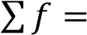250 |  | 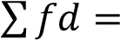688 | 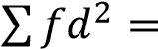12320
    - ̅ ∑
∑
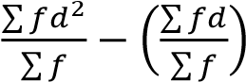
    - Var(x) =
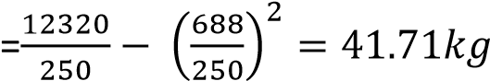
    - S.d = 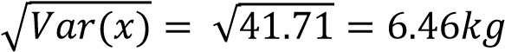

Example 14
The following table shows the marks obtained by to students in a physics test marked out of 100
Marks (%) | 20 -29 | 30-39 | 40-49 | 50-59 | 60-69 | 70-79 | 80-89 | 90-100
Number of students | 4 | 6 | 2 | 5 | 7 | 8 | 5 | 2
Find
    - Mean
    - Standard deviation
    - Median and mode
    - Semi-interquartile range
    - 40th and 85th percentile range

Solution
Class boundary | x |  | f | fx | fx2 | cf
19.5-29.5 |  | 24.5 | 4 | 98 | 2401 | 4
29.5-39.5 |  | 34.5 | 6 | 207 | 7141.5 | 10
39.5-49.5 |  | 44.5 | 2 | 89 | 3960.5 | 12
49.5-59.5 |  | 54.5 | 5 | 272.5 | 14851.25 | 17
59.5-69.5 |  | 64.5 | 7 | 451.5 | 29121.75 | 24
69.5-79.5 |  | 74.5 | 8 | 596 | 44402 | 32
79.5-89.5 |  | 84.5 | 5 | 422.5 | 35701.25 | 37
89.5-99.5 |  | 94.5 | 3 | 283.5 | 26790.75 | 40
 |  |  | 40 | 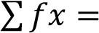2420 | 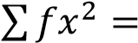164370
    - Mean ̅ ∑
∑
    - S.d = 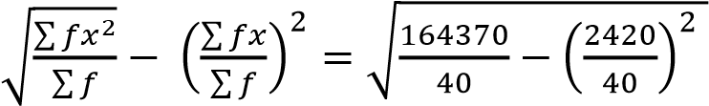 = 21.19%
    - Median 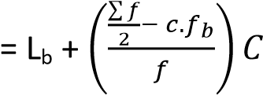
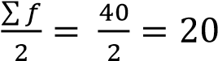
Median class boundary is 59.5-69.5, f = 7 and C = 10
Median = 59.5 + 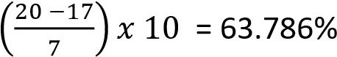
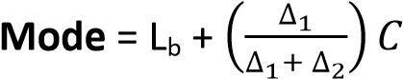
Modal class boundary is 69.5-79.5, since 8 is the highest frequency and C = 10
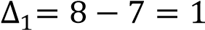 and 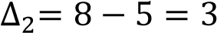
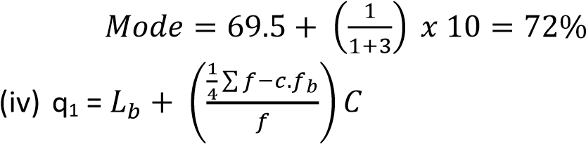
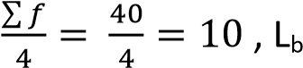=29.5, f= 6, C = 10
q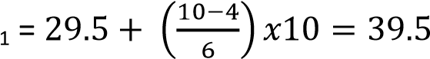
q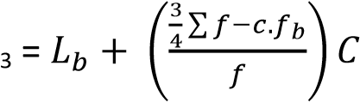
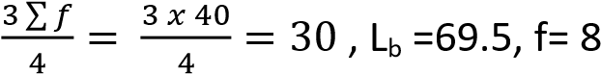, C = 10 q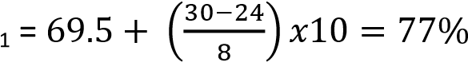
Semi-quartile range = 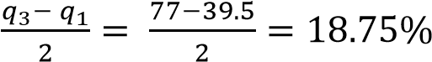
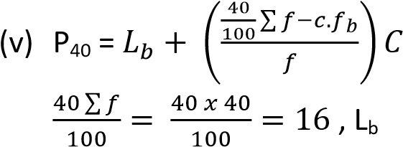=49.5, f= 5, C = 10
P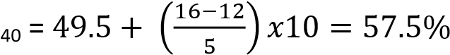
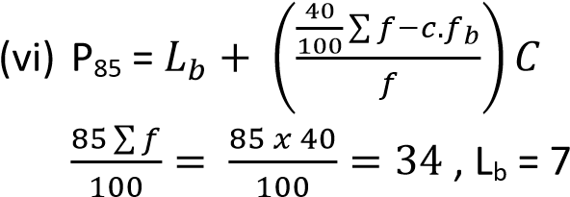9.5, f= 5, C = 10
P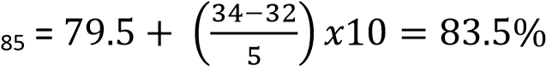
40th and 85th range = 83.5 – 57.5 = 26%
Example 15
Given the information in the table
Class | 20-29 | 30-34 | 35-44 | 45-64 | 65-74 | 75-84
Frequency | 5 | 5 | 12 | 20 | 10 | 8
Find
    - Mean value
    - Standard deviation
    - Mode
    - Median
    - Interquartile range
    - 90th percentile
Solution
Class boundary | class width | x | f | f.d | fx | fx² | cf
19.5-29.5 | 10 | 24.5 | 5 | 0.5 | 122.5 | 3001.25 | 5
29.5-34.5 | 5 | 32 | 5 | 1 | 160 | 5120 | 10
34.5-44.5 | 10 | 39.5 | 12 | 1.2 | 474 | 18723 | 22
44.5-64.5 | 20 | 54.5 | 20 | 1 | 1090 | 59405 | 42
64.5-74.5 | 10 | 69.5 | 10 | 1 | 695 | 48302.5 | 52
74.5-84.5 | 10 | 79.5 | 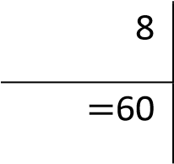  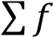 | 0.8 |  | 50562 | 60
 |  |  |  |  | 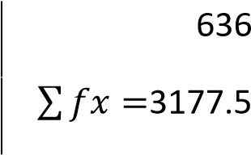 | 185113.8
    - Mean ̅ ∑
∑
    - S.d = 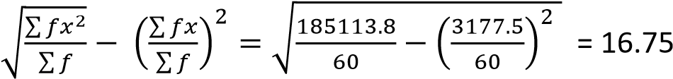
    - Mode = L_{b} 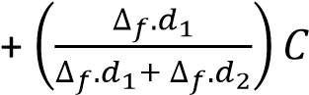
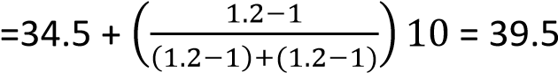
    - Median 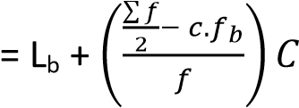
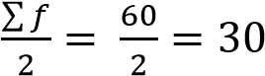
Median = 44.5 + 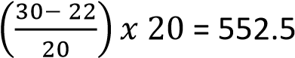

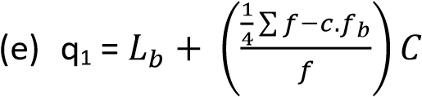
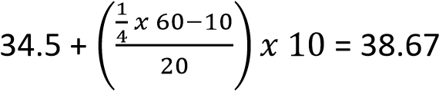
Q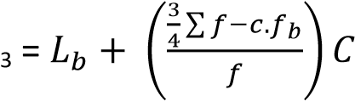
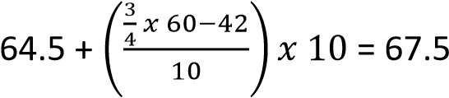
Interquartile range = 67.5 – 38.67 = 28.83
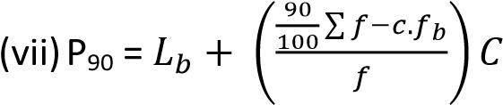
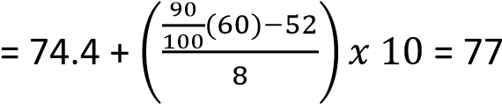
Example 17
Given the data below
Marks | 5-14 | 15-24 | 25-34 | 35-44 | 45-54 | 55-64 | 65-74 | 75-85 | 85-94
Frequency | 3 | 7 | 12 | 20 | 30 | 15 | 8 | 3 | 2
Draw a histogram and use it to determine the mode
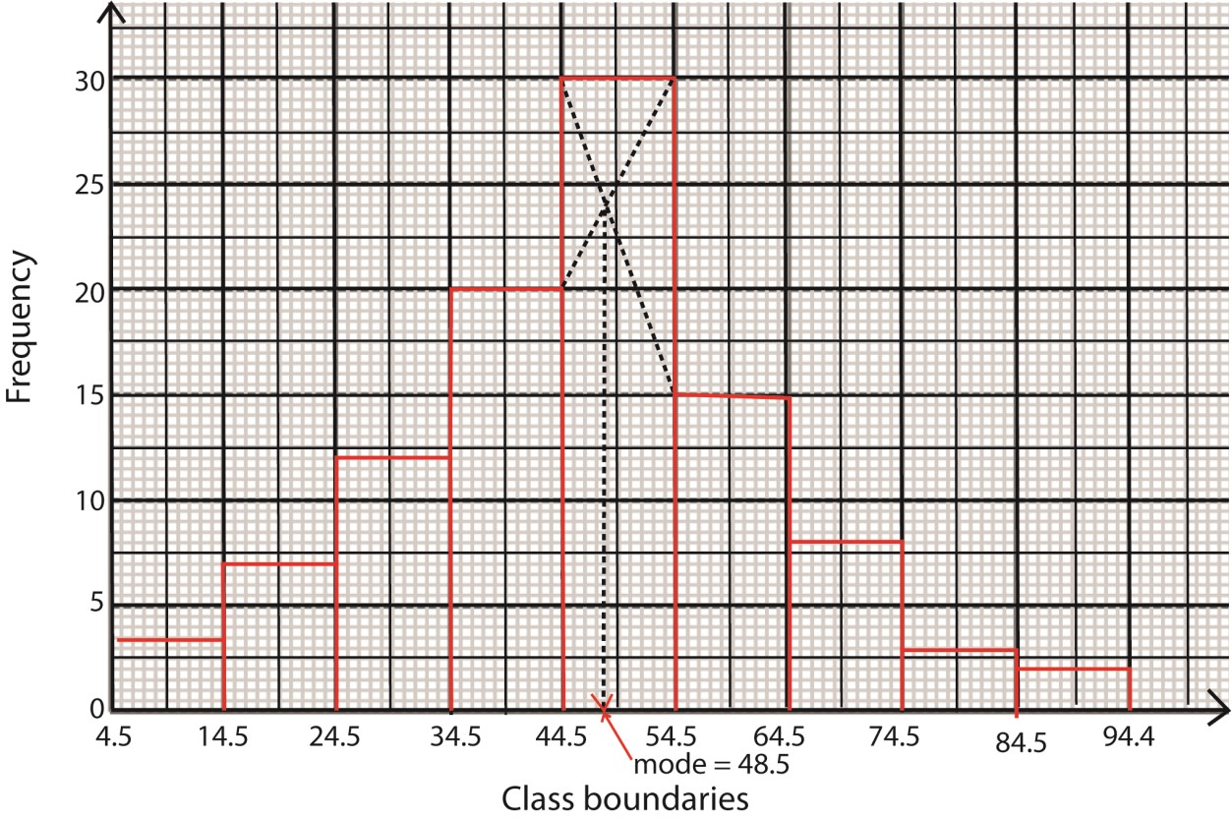
Example 18
Given the data below
Marks | 20-29 | 30-39 | 40-49 | 50-59 | 60-69 | 70-79
Frequency | 4 | 6 | 12 | 8 | 7 | 3
Draw an Orgive and use it to determine
    - Median
    - Interquartile range
    - 10th percentile
Solution
Class boundary | 19.5 – 29.5 | 29.5–39.5 | 39.5–49.5 | 49.5 – 59.5 | 59.5 – 69.5 | 69.5 – 79.5
cf | 4 | 10 | 22 | 30 | 37 | 40
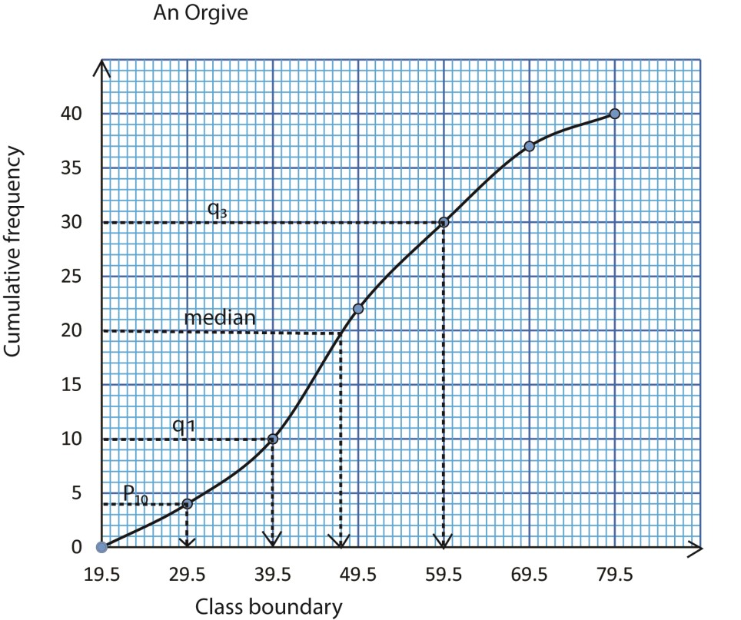
(a) The median = 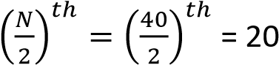^{th} value from the graph = 48.5
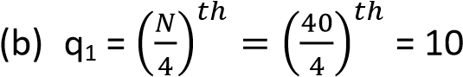
th
value ; from the graph q₁ = 39.5
q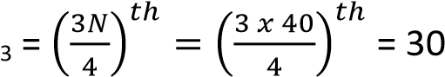^{th} value; from the graph q₃ = 59.5
Interquartile range = 59.5 – 39.5 = 20
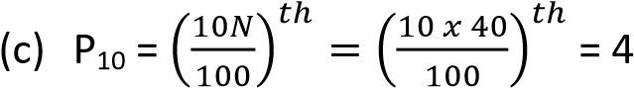
th
value ; from the graph P₁₀ = 29.5

Revision Exercise 2 (answers are given in brackets besides the questions)
- The table below shows cumulative distribution of ages (in years of 400 student
Age(years) | <12 | <13 | <14 | <15 | <16 | <17 | <18 | <19
Cumulative frequency | 0 | 27 | 85 | 215 | 320 | 370 | 395 | 400
  - Construct a cumulative frequency curve
  - Use the curve to estimate
  - Median age (Answer 14.9)
  - 20th and 80th percentile range (Ans. 2.1)
- The table below shows the time taken by students to solve a mathematics problem
Time (mins) | 5-9 | 10-14 | 15-19 | 20-24 | 25-29 | 30-34
Frequency | 5 | 14 | 30 | 17 | 11 | 3
  - Draw a histogram and use it to estimate the modal time. (ans. 17.3)
  - Find the mean and standard deviation of solving the problem (Mean = 18.5mins, s.d = 5.9896 (4D))
- The frequency distribution table shows the heights of s.6 students measured to the nearest cm;
Height | 149-152 | 153-156 | 157-160 | 161-164 | 165-168 | 169-172 | 173-176
Frequency | 5 | 17 | 20 | 25 | 15 | 6 | 2
  - Calculate
    - Mean height (Ans. 160.9cm)
    - Standard deviation (Ans. 5.5873)
  - Draw a cumulative frequency curve and use it to estimate the median (Ans. 161cm) and range of height of the middle 60% of the candidates. (Ans. 10cm)
- The table below the weights of some S.5 students from a certain school
Weight | 50-53 | 54-57 | 58-61 | 62-65 | 66-69 | 70-73 | 74-77 | 78-81
Number  of student | 3 | 8 | 12 | 18 | 11 | 5 | 2 | 1
  - Calculate
    - Mean (63.1kg)
    - Standard deviation of students’ weight (6kg)
  - Draw a cumulative frequency curve and use it to estimate
    - Median weight (63.1kg)
    - Number of students with weight between 58.9kg and 66.7kg (29students

- The table below is the distribution of weights of a group of animals
Mass (kg) | Frequency
21-25 | 10
26-30 | 20
31-35 | 15
36-40 | 10
41-50 | 30
51-60 | 45
66-74 | 5
  - Draw a cumulative frequency curve to estimate semi-quartile range (24kg)
  - Find
    - Mode (28.8333kg)
    - Standard deviation (11.772)
- The table below shows the amount of money (in thousands of shillings) that was paid out as allowances to participants during a certain workshop
Amount  (shs’000s) | 110-114 | 115-119 | 120-129 | 130-134 | 135-144 | 145-159
Number of participants | 13 | 20 | 32 | 17 | 16 | 12
  - Draw a histogram and use it to estimate the modal allowance (shs. 11800) (b) Calculate the:
    - Median allowance (shs. 126,375/=)
    - Mean allowance (shs. 128,000/=)
- The table below shows the income of 40 factory workers in millions of shillings per annum
1.0 | 1.1 | 1.0 | 1.2 | 5.4 | 1.6 | 2.0 | 2.5
2.1 | 2.2 | 1.3 | 1.7 | 1.8 | 2.4 | 3.0 | 2.2
2.7 | 3.5 | 4.0 | 4.4 | 3.9 | 5.0 | 5.4 | 5.3
4.4 | 3.7 | 3.6 | 3.9 | 5.2 | 5.1 | 5.7 | 1.5
1.6 | 1.9 | 3.4 | 4.3 | 2.6 | 3.8 | 5.3 | 4.0
  - Form a frequency distribution table with class interval of 0.5millin shillings starting with the lowest limit of 1million shillings
  - Calculate the
    - Mean income (shs. 3,175,000)
    - Standard deviation (shs. 1,413,992.574)
  - Draw a histogram to represent the above data. Use it to estimate the modal income Modal income: (shs. 5, 200,000)

- The table below shows the mars obtained by students in a physic test
Marks (%) | 25-29 | 30-34 | 35-39 | 40-44 | 45-49 | 50-54 | 55-59 | 60-64 | 60-69 | 70-74
Frequency | 9 | 12 | 10 | 17 | 13 | 25 | 18 | 14 | 8 | 8
  - Draw a histogram and use it to estimate the modal mark. (52.5)
  - Find the
    - Mean mark (49.4627)
    - Standard deviation (12.424)
- The table below shows the marks obtained in an examination by 200 candidates
Marks(%) | 10-19 | 20-29 | 30-39 | 40-49 | 50-59 | 60-69 | 70-79 | 80-89
Number of candidates | 18 | 34 | 58 | 42 | 24 | 10 | 6 | 8
  - Calculate the
    - Mean mark (40.2%)
    - Modal mark (35.5%)
  - Draw a cumulative frequency curve for the data. Hence estimate the lowest mark for a distinction one if the top 5% of the candidates qualify for the distinction. (75%)
- A class performed on an experiment to estimate the diameter of a circular object. A sample of five students had the following results in centimetre. 3.13, 3.16, 2.94, 3.33 and 3.0.
Determine the sample;
    - Mean (3.11)
    - Standard deviation (0.1356)(05marks)
- The times taken for 55 students to have their lunch to the nearest minute are given in the table below
Time (minutes) | 3 -4 | 5-9 | 10-19 | 20 – 29 | 30 – 44
Number of students | 2 | 7 | 16 | 21 | 9
    - Calculate the mean time for the student to have lunch. (mean=20.65) (04marks)
    - (i) Draw a histogram for the given data
(ii) Use your histogram to estimate the modal time for the students to have lunch. (08marks) (modal time = 22 minutes)

- The frequency distribution below shows the age of 240 students admitted to a certain University.
Age (years) | Number of student
18 - < 19 | 24
19 -< 20 | 70
20 -< 24 | 76
24 -< 26 | 48
26 -< 30 | 16
30 -< 32 | 6
    - Calculate the mean age of the students. (mean =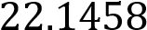 )(04mark)
    - (i) Draw a histogram for the given data
(ii) Use the histogram to estimate the modal age (modal age = 19.58) (08mark)
- The table shows the masses of bolts bought by a carpenter.
Mass (grams) | 98 | 99 | 100 | 101 | 102 | 103 | 104
Number of bolts | 8 | 11 | 14 | 20 | 17 | 6 | 4
Calculate the:
(a)median mass (101g)
(b) mean mass of the bolt(100.7625g) (05mark
- The table below shows the marks obtained in a mathematic test by a group of student
marks | 5 -<15 | 15-<25 | 25-<35 | 35-<45 | 45-<55 | 55-<65 | 65-<75 | 75-<100
Number of students | 5 | 7 | 19 | 17 | 7 | 4 | 2 | 3
    - Construct a cumulative frequency (O give) for the data (05 marks)
    - Use your Ogive to find the
      - Range between the 10th and 70th percentiles (26)
      - Probability that a student selected at random scored below 50 marks. 0.8125) (07 marks)
- The table below shows the marks obtained by 100 students in a mathematics test
Marks | 20-<40 | 40-<50 | 50-<55 | 55-<60 | 60-<70 | 70-<90 | 90-<100
Number of students | 5 | 15 | 10 | 15 | 25 | 25 | 5
  - Calculate the mean mark (63.125)
  - Construct a cumulative frequency curve (Ogive) and use it to find the
    - Median mark (61.5)
    - Range of the middle 40% of the mark (15)

